**Global Education Investment vs Economic Output (2012-2022)**

1. **The problem:**

**The Problem: The ROI of Human Capital**

Global economic inequality remains a systemic challenge. While the consensus among international bodies is that education is the primary "lever" for upward mobility, the actual **Return on Investment (ROI)** of national education spending is rarely quantified. Governments allocate trillions of dollars to education, but do these fiscal efforts translate into immediate economic prosperity?

**The Objective**

This project analyzes a decade of global data to bridge the gap between **fiscal input** (spending as a % of GDP) and **economic output** (GDP per Capita and Purchasing Power Parity).

**The Core Question**

**Does increased investment in education act as a leading indicator for improved global economic conditions?** To answer this, I processed 10 years of longitudinal data to identify if wealth is a byproduct of education, or if education is a luxury afforded by existing wealth.

**2. Executive Summary:**

**Bottom Line:** The data largely supports **H3**. While a positive long-term correlation exists, education investment is not a guaranteed driver of immediate wealth. Only **21% of nations** successfully translate high investment into high economic output (PPP), revealing a significant "Efficiency Gap."

* **The Investment Effort Paradox:** Many lower-middle-income nations (e.g., Tuvalu, Kiribati) lead the world in spending % but remain in the bottom tiers for PPP.
* **Growth Decoupling:** Over the last decade, Global Median PPP grew by **63%**, while education investment remained stagnant (~0% net growth). This proves that recent wealth surges are fueled by factors other than current educational spending (e.g., infrastructure, trade, and stability).
* **The Verdict:** **H1 is rejected** as a short-term rule. Education is a necessary long-term catalyst, but not a sufficient standalone driver for 10-year economic trends.

**3. Methodology**

To investigate the ROI of human capital, I conducted a longitudinal study using the following framework:

* **Primary Data Source**: All raw datasets were extracted from the **World Bank’s Public Repository**, ensuring a globally standardized and authoritative foundation for the analysis.
* **Metric Selection**: I identified and isolated three primary pillars to evaluate the relationship between fiscal effort and economic outcomes:
  + **Education Investment (% of GDP)**: Serves as the primary "Input" metric, measuring a nation's relative fiscal commitment to human capital.
  + **GDP Per Capita**: Used as the baseline measure of a country’s total economic output relative to its population size.
  + **PPP (Purchasing Power Parity)**: Employed as the "Living Standards" metric to adjust for international cost-of-living differences, providing a more realistic view of economic power.
* **Analytical Objective**: The goal was to move beyond simple correlation and determine if high-investment nations consistently translate that spending into superior purchasing power for their citizens.

**3.2 KPIs selected for the study:**

To ensure the study remained objective and measurable, I defined five core KPIs to guide the technical execution in SQL and the visual storytelling in Power BI:

* **Global Median of Education Spending**: Established the "Neutral Point" of global fiscal effort, allowing for the classification of nations as either "High Investors" or "Under-investors" relative to the world average.
* **Investment and PPP Alignment (The Efficiency Metric)**: Functioned as the study's primary success indicator, quantifying the percentage of nations that successfully converted high fiscal input into high economic output.
* **Top Investor Identification**: Isolated the "Extreme Performers" to test if the world's highest spenders (by % of GDP) were also the world's wealthiest nations, or if they represented a specific regional outlier.
* **Data Coverage Tracker**: Maintained analytical transparency by monitoring the sample size (e.g., 168 countries), ensuring that the conclusions remained statistically significant across different time-slices.
* **Year-over-Year (YoY) Momentum**: Calculated for all three primary metrics (PPP, GDP, and Education %) to identify if global wealth was growing faster than the investments intended to drive it.

**3.3 – ETL Pipeline**

The technical architecture of this project was designed to ensure data integrity while maintaining the flexibility needed for multi-dimensional analysis. The process followed a linear, four-stage progression:

**1. Excel: Initial Data Sanitization**

* **Unpivoting**: Transformed the World Bank’s "Wide" format (where years were columns) into a "Long" format suitable for relational databases.
* **Entity Classification**: Standardized country names and filtered out non-country entities (e.g., "World," "High Income") to prevent aggregate inflation in the dataset.

**2. SQL (MySQL): Advanced Transformation & Logic**

* **Feature Engineering**: Used **CTEs (Common Table Expressions)** to calculate the 10-year global benchmarks for PPP and Education Spend.
* **Time-Series Logic**: Leveraged **Window Functions** (LAG) to compute Year-over-Year (YoY) growth rates, identifying economic momentum across 168 nations.
* **Null Management**: Implemented COALESCE and NULLIF to handle reporting gaps in the World Bank data, ensuring zero-division errors did not occur during growth calculations.

**3. Power BI: Modeling & Visualization**

* **Power Query**: Conducted final data type adjustments and established the relationship between the fact table and metadata.
* **DAX Implementation**: Engineered custom measures for the **Efficiency Alignment** (%) to dynamically categorize nations into the "Top Performer" quadrant.
* **Interactive UI**: Developed a multi-tab experience (Main Page, Top/Bottom 5, World Map, and Insights) to cater to different levels of stakeholder technicality.

**4. Synthesis: Pattern Recognition & Hypothesis Testing**

* **Insight Consolidation**: Assembled individual data points into broader trends, such as the **63% PPP growth surge**.
* **The "Final Answer"**: Compared the empirical evidence against the initial hypotheses to determine that **Hypothesis 3 (Ecosystem View)** was the most accurate representation of global ROI.

**4.1.1 Excel – Initial Cleaning & Structuring**

The original World Bank datasets were formatted for human readability but were not structured for database ingestion or relational modeling. My goal was to transform these static tables into a clean, long-format structure compatible with SQL and Power BI.

I focused on three practical steps:

* **Data Normalization (Unpivot):** The source files had years as horizontal columns. I used Power Query to unpivot the data, bringing all years into a single column. This was essential for performing any chronological or time-series analysis.  
    
  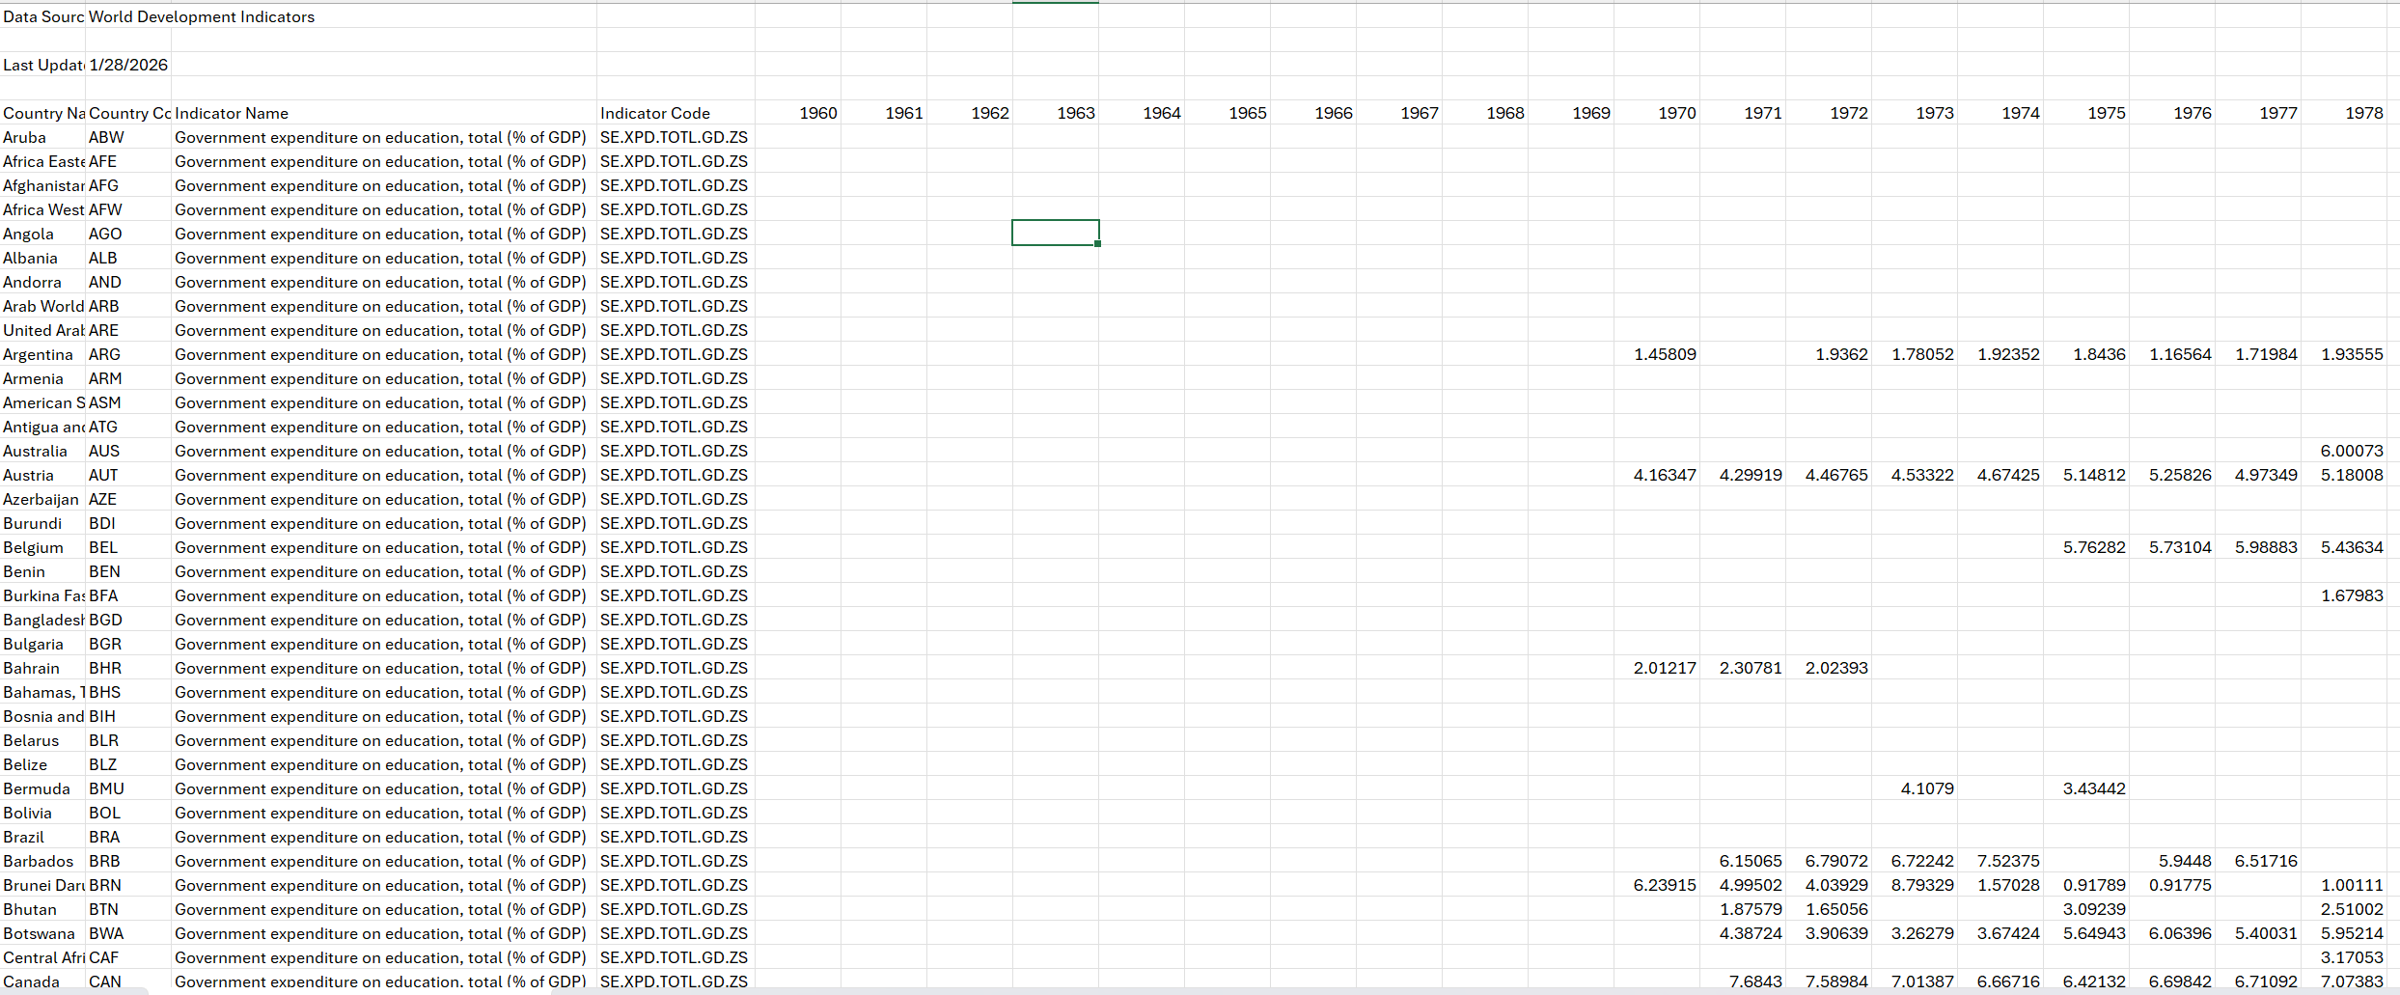
* **Removing Noise:** I promoted headers and stripped out null columns and redundant rows that would otherwise cause import errors or inflate the file size.
* **Data Type Validation:** I manually assigned data types (Decimal for metrics, Integer for years) at this early stage to prevent calculation mismatches during the SQL and DAX phases.

**4.1.2 Excel – Initial cleaning on Fact table**

The raw data included a mix of individual countries and broad regional aggregates (e.g., "Africa Eastern & Southern ," "South Asia"). If left uncleaned, this would cause "double-counting" errors, as the regional totals would be added alongside their constituent countries.

To fix this, I focused on the following steps:

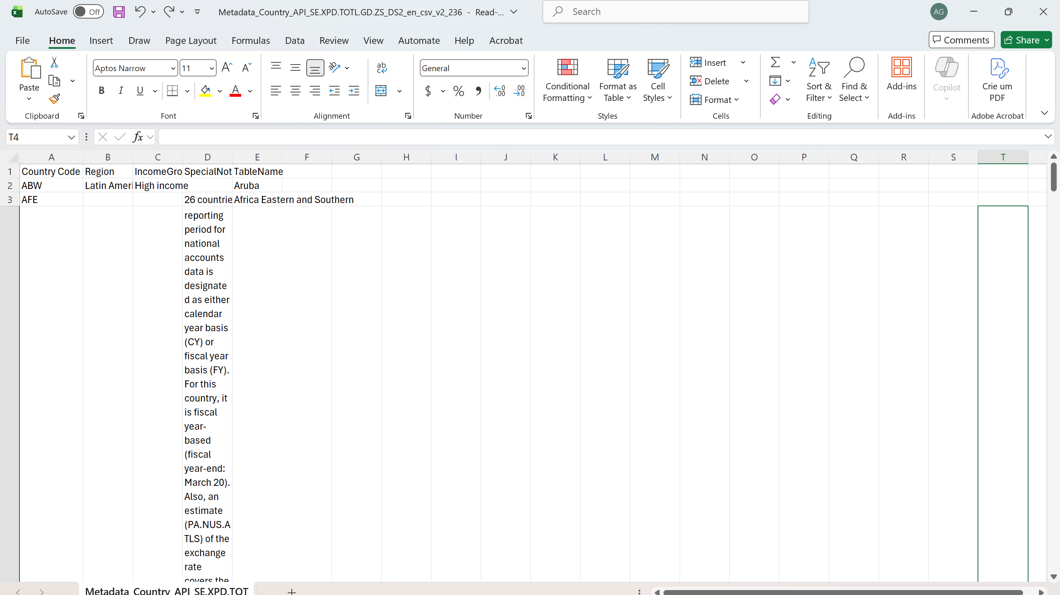

To fix this, I focused on the following steps:

* **Entity Categorization:** I noticed that regional aggregates had no value in the 'Region' column. I used the ISBLANK function to create an **'Entity_Type'** flag. This allows me to easily distinguish between a single 'Country' and a 'Region' aggregate.
* **Data Accuracy:** This classification ensures that when I build the dashboard, I can filter for specific nations without the regional totals inflating the numbers.
* **Final Power Query Pass:** I used Power Query to enforce strict data types (ensuring numbers didn't import as text) and removed any remaining null rows that could break the SQL import later.

**Result:** A clean dataset with a logic-based flag to handle geographic levels, preventing overlapping data and ensuring all future totals are mathematically sound.

**4.2 SQL – Advanced ETL & Analytical Pre-calculation**

Once the data was in SQL, I moved beyond basic storage to focus on preparing the metrics for analysis. My goal was to use SQL’s processing power to handle the "heavy lifting" before the data reached Power BI.

* **Metric Pre-calculation:** I calculated baseline KPIs directly in the database. This ensures that the core numbers remain consistent, regardless of how they are filtered later in the reporting pipeline.
* **Cross-Validation:** I used SQL as a "source of truth" to verify my Power BI results. By comparing SQL query outputs with DAX measure results, I could quickly spot and fix any calculation errors.
* **Gap Analysis & Alignment:** During the initial queries, I audited the time-series structure to ensure the years were perfectly aligned. This was a critical step to make sure the subsequent Window Functions for Year-over-Year (YoY) growth would work accurately.

**Result:** A high-integrity dataset where the most complex logic is handled at the database level. This makes the final dashboard faster and ensures that all metrics are verified against the raw SQL output.

**4.2.1 SQL – Schema Cleanup & Syntax Adjustment**

When migrating the data from Excel to SQL, I immediately ran into syntax issues caused by the original column headers. Standard Excel names like "Country Name" contain spaces, which are problematic for writing clean SQL queries.

* **Standardizing Identifiers:** I used ALTER TABLE statements to rename columns across all tables, replacing spaces with underscores (e.g., country_name).
* **Workflow Efficiency:** This step was necessary to prevent constant execution errors and to make the code easier to write and maintain during the more complex calculation phases.

**Result:** A clean, query-ready schema that follows SQL best practices, ensuring that all downstream scripts run without formatting errors.

**4.2.2 SQL – Global Average Benchmark (2022)**

Once the schema was ready, I calculated the global average for education investment in 2022 to establish a baseline for the project.

* **Methodology:** I used the AVG function filtered for the 2022 period to determine the global mean across all countries.
* **Validation Anchor:** This simple SQL calculation served as a "sanity check" for the more complex median and weighted calculations I would later perform in Power BI.
* **Data Integrity:** By comparing this SQL result with my Power BI visuals, I was able to confirm that the data had imported correctly and that my initial DAX logic was sound.

**Result:** A verified global benchmark that ensured the accuracy of the reporting layer and helped catch any logic errors early in the transition from SQL to Power BI.

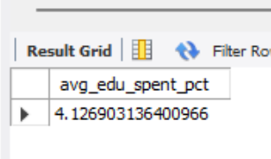

**4.2.3 SQL – Investment & PPP Alignment (Efficiency Benchmark)**

This stage focused on identifying the correlation between educational investment and national wealth (PPP). The goal was to isolate countries exceeding global averages in both metrics to establish an "Efficiency Benchmark."

* **Logic Implementation:** I performed an in-table transformation to create binary flags for each country. By comparing individual country data against the global mean, I categorized performance into a "High/Low" framework.
* **Analytical Goal:** This pre-calculation in SQL allowed for a rapid assessment of which nations successfully translated high education spending into superior purchasing power.
* **Database Efficiency:** By flagging these records at the database level, I reduced the computational complexity required in the visualization layer, ensuring a faster and more responsive final dashboard.

**4.2.3 SQL – Top Investor Identification (2022)**

To provide context in the final report, I needed to identify which country led the world in education investment relative to its GDP. This gave me a clear benchmark to compare all other nations against.

* **Query Strategy:** I used the MAX function and sorted the results in descending order (DESC) to rank the countries by their spending percentages.
* **Result Isolation:** I applied a LIMIT 1 clause to isolate the top-performing outlier for the 2022 fiscal year.
* **Outcome:** This identified the **Marshall Islands** as the global leader. Finding this figure in SQL allowed me to verify the ranking before building the bar charts and cards in Power BI.

**Result:** A validated top-tier benchmark used to anchor the rankings in the dashboard, ensuring the "top spot" was mathematically verified before visualization.

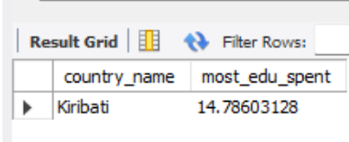

**4.2.4.1 – SQL – YoY Expenditure Trend – The YoY change in the global Average Education Spending (2022)**

To analyze the Year-over-Year (YoY) variation in global education spending, I moved from a specific 2021–2022 calculation to a scalable structure that supports long-term trend analysis.

* **Initial Approach:** I used Common Table Expressions (CTEs) to isolate the averages for 2021 and 2022. This kept the query organized and much easier to read than nested subqueries.
* **Formula Logic:** I applied the standard growth formula to calculate the percentage difference between the two periods:



In the end, I found the following results:

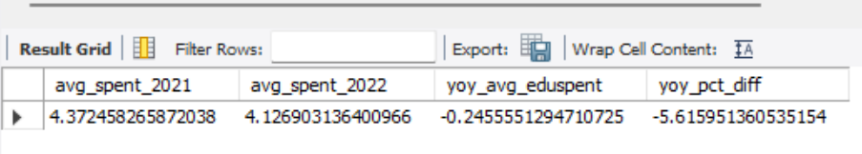

* **Scalability**: I realized that calculating a single delta wasn't enough for a dynamic report. I pivoted to adding pre-calculated YoY growth columns across all fact tables to support multi-year filtering.

**Result**: By embedding these calculations directly into the SQL schema, I optimized the model for deep trend analysis. This ensures that Power BI can display historical growth instantly without needing heavy DAX processing during runtime.

**4.2.4.2 – SQL – YoY Delta for all metrics.**

To support comprehensive trend analysis, I engineered the datasets to calculate annual deltas at the row level. This moved the logic from static, one-time calculations to a dynamic format that handles multi-year comparisons natively.

* **Methodology:** I used a Common Table Expression (CTE) combined with the LAG window function to access historical data.
* **Logic Execution:** By using LAG(value) OVER (PARTITION BY country_code ORDER BY year), I was able to align the current and previous year's data on a single row. This approach avoids the performance cost of expensive self-joins.
* **Error Handling:** I integrated the NULLIF function into the growth formula to handle cases where previous data might be missing or zero. This ensures the query is production-ready and prevents "division-by-zero" errors.



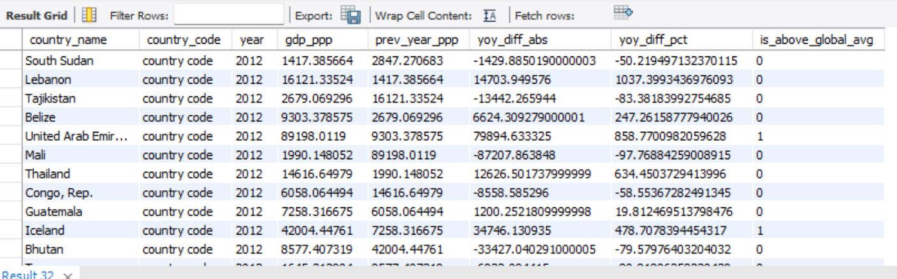

**Result:** Pre-calculating these differences in SQL significantly reduced the need for complex DAX measures. This resulted in a faster, more performant Power BI report that handles time-series analysis with minimal lag.

**4.2.5 SQL – Data Coverage & Sample Validation**

Establishing the study's scope is fundamental to its statistical significance. This KPI defines the total number of unique nations analyzed, serving as the denominator for all subsequent proportion-based metrics.

* **Methodology:** Performed a COUNT aggregation on the metadata table to determine the total sample size.
* **Granularity Control:** Leveraged the **'Entity_Type'** logic by applying a WHERE Region IS NOT NULL clause. This filtered out regional aggregates to ensure the count strictly reflected individual nations.
* **Analytical Purpose:** Validating this coverage was critical for establishing the baseline for the **Efficiency %** calculations, ensuring that all country-level proportions in the final dashboard are mathematically accurate.

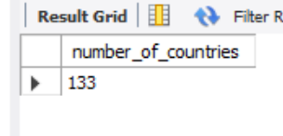

**Result:** A verified total sample size of individual countries, providing a transparent and robust foundation for global comparison.

**4.2.6 – SQL – Percentage of countries above the PPP average in the last 10 years.**

While this metric was intended for the final dashboard, I first calculated it in SQL to test a multi-layered data approach. The goal was to identify what percentage of countries consistently maintained a GDP (PPP) above the global average over the last decade.

* **Architecture:** I used a CTE-driven structure to separate the 10-year global average from individual national data. This ensured the comparison was made across the exact same time frame for every country.
* **Optimization:** I implemented a CROSS JOIN to append the global benchmark to every row. This eliminated the need for repetitive subqueries and simplified the final comparison logic.
* **Conditional Logic:** I used a CASE WHEN statement to assign binary values (1 or 0) to countries exceeding the benchmark, allowing for a clean percentage calculation directly in the database.

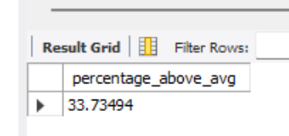

**Result:** I successfully validated the "Efficiency Metric" at the database level. This proved that complex, multi-year transformations can be handled in the SQL layer, significantly reducing the processing load and complexity within Power BI.

**4.2.7 SQL – Final Export & Integration**

This final SQL step marked the transition from data engineering to business intelligence. At this stage, the raw data had been transformed into "analysis-ready" tables, specifically optimized for the Power BI reporting layer.

* **Performance Optimization:** By embedding complex time-series logic and entity flags directly into the SQL schema, I moved the computational burden away from Power BI.
* **ETL Completion:** I exported the optimized datasets into a standardized CSV format and imported them into Power BI, completing the full ETL (Extract, Transform, Load) cycle.
* **Maintenance & Speed:** Handling the "heavy lifting" in SQL ensures the resulting Power BI model is lightweight and easy to maintain. This preparation allows for a faster, more responsive experience when users interact with the dashboard.

**Result:** A streamlined data pipeline that prioritizes backend processing. This ensures that the final dashboard is built on a high-performance foundation, capable of handling complex filtering without lagging.

**4.3 PowerBI – Power Query Refinement**

After importing the SQL-transformed datasets, I used Power Query as a final "Quality Gate." This phase ensured the schema was fully optimized and that the data types were correctly recognized by the Power BI engine.

* **Data Type Precision:** I manually verified and enforced strict data types—setting metrics to **Decimal Numbers** and years to **Integers**. This step is critical for ensuring that DAX measures perform mathematical operations accurately.
* **Schema Alignment:** I performed a final audit of headers and columns to ensure the data imported from SQL exactly matched the requirements of the Power BI model.
* **Error Prevention:** By validating the data at this stage, I eliminated the risk of "Type Mismatch" errors, which frequently occur when building relationships between different tables.

**Result:** A clean, structured data model that serves as a stable foundation for complex DAX operations and ensures all visualizations reflect the data accurately.

**5. PowerBI Modelling & DAX**

In this step, I opened the **Model View** to manually review the connections between all tables. This was a simple but essential check to make sure the structure was solid before building the visuals.

* **Manual Audit:** I looked at every relationship to spot any inconsistencies or errors in how the tables were linked.
* **Problem Prevention:** Doing this early ensures I won't have issues later with broken filters or incorrect calculations in my measures.

**Result:** A verified and stable data model where all filters work correctly and the data remains accurate throughout the dashboard.

**5.1 PowerBi – Data Model and Tables Relatonships**

I opened the **Model View** to manually check how the tables were connected. This was a quick but important step to make sure the data flowed correctly before I started building any charts.

* **Relationship Audit:** I looked at every link between the tables to find any errors or inconsistencies.
* **Manual Verification:** Even though Power BI tries to connect tables automatically, I checked the directions and types of every relationship myself to be 100% sure they were correct.
* **Preventing Errors:** This step was key to making sure that my filters wouldn't break and that my DAX formulas would show the right numbers later.

**Result:** A stable and verified model where all tables are correctly linked, ensuring that the dashboard is accurate and the filters work exactly as they should.

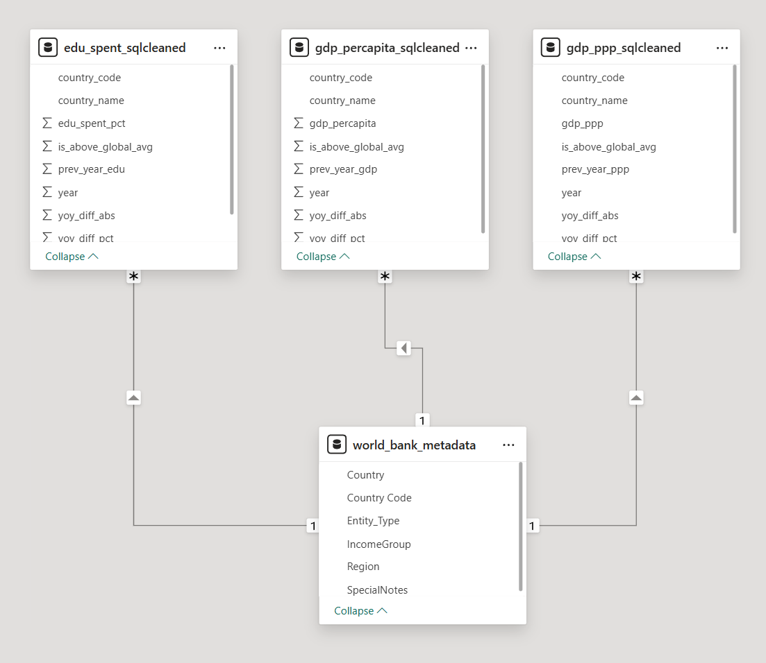

**5.1.1 Relationship Audit & Key Standardization**

I opened the **Model View** to double-check the automatic connections Power BI created. I wanted to make sure everything was solid so I wouldn't run into errors or wrong numbers later.

* **Fixing Names:** I noticed that the columns used to link tables had different names (like country_name in one table and TableName in another).
* **Standardizing Keys:** I went back into Power Query to rename these columns so they matched across the whole model.
* **Why it matters:** Standardizing these "keys" makes the relationships much stronger. It prevents the model from getting confused and ensures that filters work perfectly.
* **Better Performance:** Using a clean "One-to-Many" structure helps Power BI run faster and makes the model much easier for anyone to understand and manage.

**Result:** A clean, standardized model where all tables connect logically, ensuring the dashboard is fast and the data is always accurate.

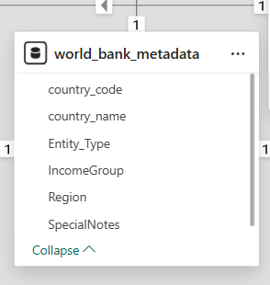

**5.1.2 Relationship Integrity & Logic Correction**

After cleaning up the column names, I took a close look at how each table was actually talking to the others. I noticed that Power BI’s automatic settings had made a mistake that would have ruined the calculations.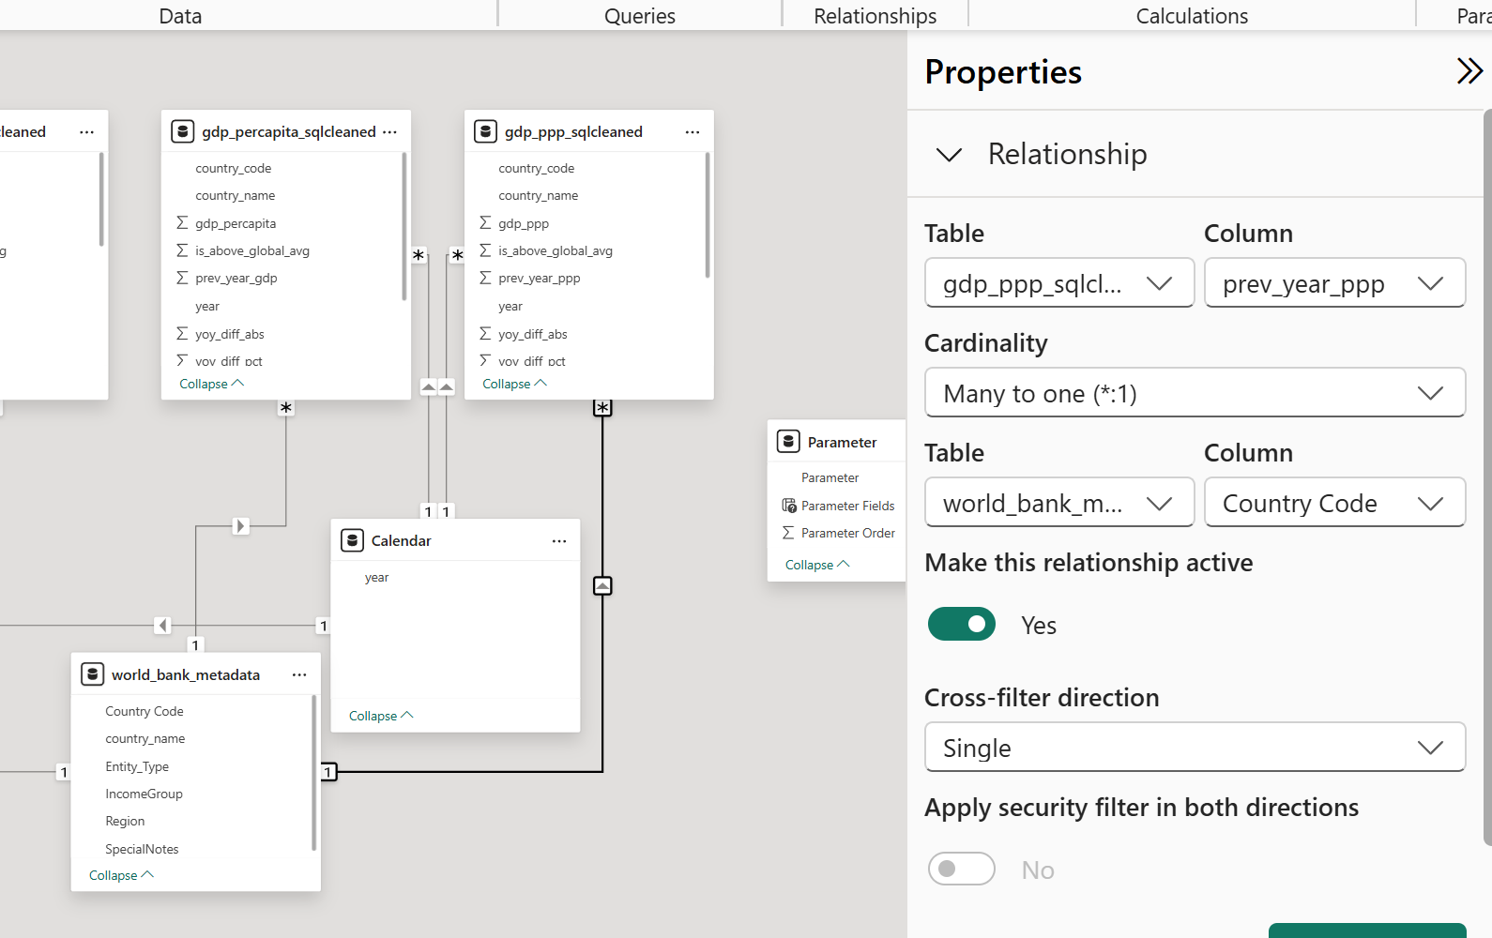

* **Finding the Error:** I found that the GDP table was accidentally linked using the "previous year" column instead of the unique "country code."
* **Manual Fix:** I went into the **Properties menu** and manually changed the connection so it mapped correctly to the country_code.
* **Why it matters:** If I hadn't caught this, the charts for GDP and Education would have shown the wrong data for the wrong years.
* **Accuracy:** This simple check ensured that when you filter by a country, all the data across the different charts stays perfectly in sync.
* **Result:** A verified and reliable model where every table is linked correctly, ensuring the final dashboard shows the truth instead of skewed numbers.

**5.1.3 Calendar Table: The "Single Source of Truth"**

* As I built more formulas, I noticed that using different "Year" columns from different tables was causing errors. To fix this, I created one central Calendar Table to handle all dates in one place.

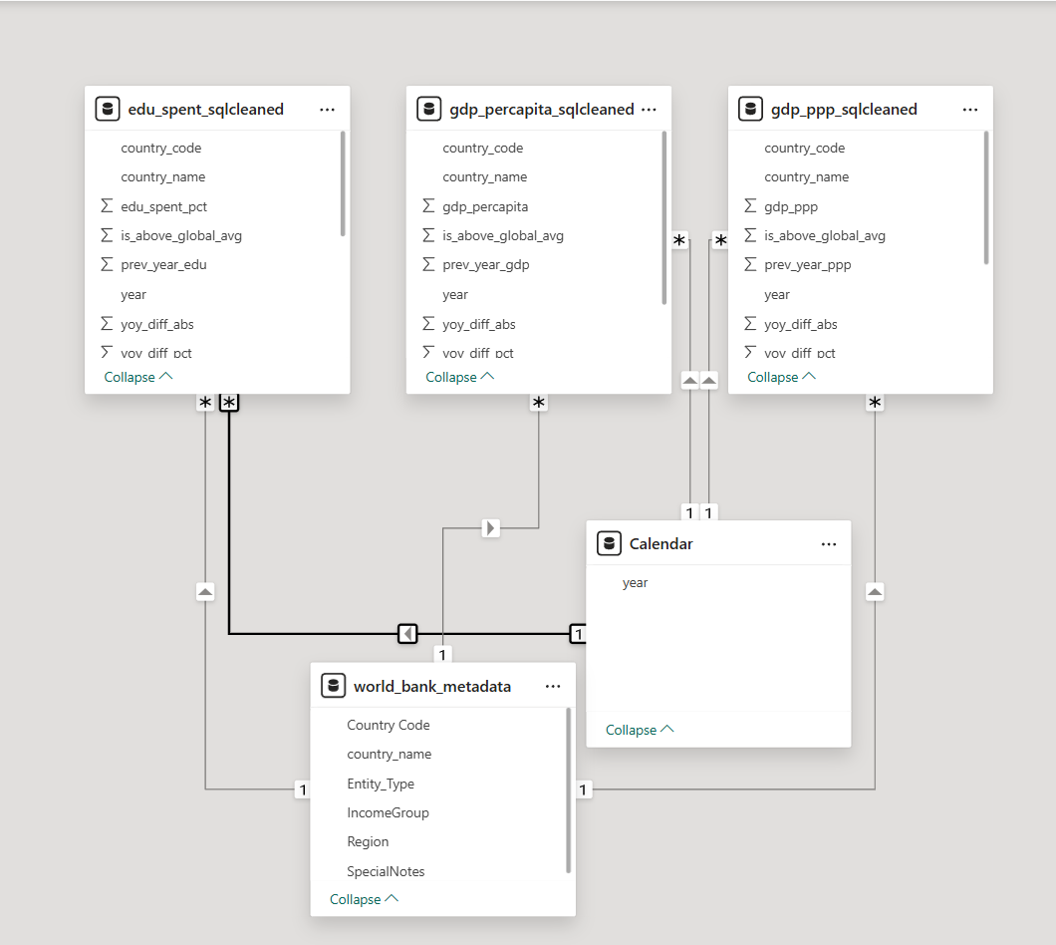

* **Model View Setup:** I went into Model View and manually linked this new Calendar "Year" to every other table using a One-to-Many relationship.
* **Syncing the Dashboard:** This ensures that when a user picks a year on a slicer, every chart on the page—from Education to GDP—updates at the exact same time.
* **Preventing "Blank" Results:** This simple alignment stops the common problem of getting "Zero" or "Blank" values caused by tables not being in sync.

**Result:** A perfectly synchronized report where all data stays aligned, making the dashboard reliable and much easier to use.

**5.2 PowerBI – DAX Dictionary**

Initially, I planned to do most of the work in SQL so the data would be "ready to go" when it hit Power BI. My goal was to keep things simple and focus mostly on the charts and design.

* **The Shift to DAX:** As I built the dashboard, I realized that while SQL is great for cleaning data, I still needed DAX to make the report interactive.
* **Dynamic Results:** I had to create specific DAX formulas to allow the charts to change instantly when a user picks a year or compares different countries.
* **The Right Balance:** This taught me that a good project needs both: SQL to build a strong foundation and DAX to give the user the flexibility to explore the data.

**Result:** A balanced and interactive report that combines the speed of pre-processed SQL data with the dynamic power of DAX calculations.

**5.2.1 PowerBI – DAX Dictionary – Calendar**

While building advanced formulas, I noticed that filtering by year wasn't working correctly because the data was spread across four different tables. To fix this, I built a centralized **Calendar Table** to act as the main timeline for the whole project.

* **How I Built It:** I used the VALUES function to pull unique years from the Education, GDP, and PPP tables. Then, I used UNION and DISTINCT to merge them into one clean, duplicate-free list.
* **Creating the Link:** This new table allowed me to create strong **One-to-Many** relationships. I linked this single "Year" column to all my other data tables in the Model View.
* **The Benefit:** This fixed the issue where some charts would show "zero" or "blank" values. Now, when a user selects a year, every single metric in the report updates in perfect sync.

**Result:** A synchronized model that eliminates calculation errors and ensures a smooth, reliable experience for anyone using the dashboard.

**5.2.2 PowerBI – DAX Dictionary– Global Median Education**

For the first major KPI, I used the MEDIAN function to calculate global education spending. Using a median instead of a regular average is better here because it prevents a few extremely high-spending countries from skewing the results.

* **SQL vs. Power BI:** In SQL, I used AVG because standard SQL doesn't have a built-in median function. In Power BI, I was able to use the native MEDIAN function for a more balanced view.
* **Double-Checking the Data:** To make sure my data was correct, I temporarily changed my DAX formula to AVERAGE. I confirmed that the result perfectly matched my SQL output.
* **Validation:** This "cross-check" between SQL and Power BI gave me total confidence that my data was accurate before I finalized the median as the main benchmark.

**Result:** A verified, reliable benchmark that provides a realistic look at global spending by neutralizing the impact of outliers.

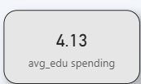

This formula was also used further used for other calculations.

**5.2.3 PowerBI – DAX Dictionary – Education Investment Efficiency**

This is the most important KPI in the study. It looks for a link between how much a country spends on education and its actual wealth (Purchasing Power). The goal is to see if countries that invest more in education also tend to have a higher GDP (PPP).

* **The Logic:** I wanted to identify the percentage of countries that are "above average" (specifically, above the global median) in both education spending and wealth.
* **Why DAX instead of SQL:** While I originally flagged these countries in SQL, I rebuilt the logic in Power BI. This allows the "Efficiency %" to update instantly when a user changes the year or filters by region on the dashboard.
* **Using the Median:** Just like the previous measure, I used the **Median** as the benchmark. This makes the results much more realistic because it prevents a few extremely rich countries from making the "average" too high for everyone else.

**Result:** A dynamic, high-impact metric that proves the value of educational investment. Because it’s built-in DAX, it stays accurate no matter how the user filters the report.

**5.2.3.1 Power BI – DAX Dictionary: Global Education & PPP Medians**

To figure out which countries are "top performers," I first needed to set a global benchmark for both Education Spending and Wealth (PPP).

* **Setting the Baseline:** I created two measures using the MEDIAN function to find the middle point of the global data.
* **The "ALLSELECTED" Trick:** I wrapped these formulas in ALLSELECTED so the global average stays the same for every country on a list, but still updates if the user picks a different **Year** on a slicer.
* **Dynamic Benchmarks:** This works like the "Global_Benchmark" I built in SQL, but it is much better because it is fully interactive. It provides a moving target that adjusts as the user explores different time periods.

**Result:** A smart, interactive threshold that allows the dashboard to instantly compare any country against the global average for any selected year.

**5.2.3.2 PowerBI – DAX Dictionary – Education Investment Efficiecy – Education Investment/ Wealth Flag**

To make it easy to see which countries are performing well, I created a simple "flag" system, similar to the logic I used in the SQL phase.

* **The "IF" Logic**: I used the IF function to compare each country’s stats against the global medians I set in the previous step.
* **Binary Scoring**: I assigned a **1** if a country was above the global average and a **0** if it was below. I did this for both Education Spending and Wealth (PPP).
* **Simplifying the Data**: By turning these big numbers into simple 1s and 0s, I made it much easier to calculate the final results.
* **Finding the Target Group**: This setup allows the model to instantly find and count the specific group of countries that are high-investors and high-wealth at the same time.

**Result**: A streamlined system that transforms complex economic data into simple markers, allowing for fast and accurate performance tracking across the entire dashboard.

**5.2.3.3 PowerBI – DAX Dictionary – Education Investment Efficiecy – Efficient Country Match**

After creating the flags for Education and Wealth, the final step was to see where they overlapped. I created a measure to find the specific countries that performed above the average in both categories at the same time.

* **The "AND" Logic**: I used a formula to say: if a country’s Education Flag is **1** AND its Wealth Flag is also **1**, then mark it as **1**.
* **Isolating Top Performers**: If a country didn't meet both criteria, it was marked as **0**.
* **The Goal**: This allowed me to isolate the "efficient" countries—the ones that successfully turned high education spending into high purchasing power.
* **Dashboard Value**: This calculation provides the exact data needed for the "Efficiency %" shown on the final dashboard.

**Result**: A clean list of top-performing nations that serves as the foundation for the project’s main conclusion.

**5.2.3.4 PowerBI – DAX Dictionary – Education Investment Efficiecy – Investment Efficiency %**

The final step was to calculate the actual percentage of "efficient" countries. This tells us what portion of the world (or region) managed to be above average in both spending and wealth.

* **The Calculation:** I used the DIVIDE function to calculate the result. This is a "safe" way to divide because it automatically prevents errors if there is no data to count.
* **Counting the Countries:** I used a combination of SUMX and VALUES to look at each unique country, count the "1s" from my previous flags, and divide them by the total number of countries in the list.
* **Why it’s Dynamic:** Because it’s built this way, the percentage updates instantly. If you filter for just "Europe" or just the "Year 2020," the percentage remains 100% accurate for that specific selection.

**Result:** A high-level metric on the dashboard that clearly shows how many countries are successfully converting education investment into national wealth.

**5.2.4 PowerBI – DAX Dictionary– YoY Growth Metrics**

The goal here was to track how much the global medians changed from year to year. Since I had already done the "heavy lifting" in SQL by creating a "previous year" column, building this in Power BI was much faster and more efficient.

* **Using Variables:** I used the VAR (Variable) function to keep the code clean. I created one variable for the "Current Year" and another for the "Previous Year." This makes the formula easier to read and helps it run faster.
* **Safe Division:** I used the RETURN function along with DIVIDE to calculate the percentage change.
* **Error Prevention:** Using DIVIDE is a smart way to avoid "division-by-zero" errors, ensuring the dashboard never shows broken values or "Nulls" if a specific year of data is missing.

**Result:** A reliable "Year-over-Year" growth metric that allows the user to see global trends instantly without slowing down the dashboard.

**6. Dashboard & Visualizations**

This was arguably the most crucial part of the entire project. The primary challenge was to transform extensive, multi-dimensional World Bank data into an intuitive experience for a broad audience.

To achieve this, I followed a **top-down information hierarchy**, breaking the insights into five specialized pages. This approach ensures that users can first understand global trends before drilling down into specific regional and economic complexities. My focus was on:

* **Reducing Cognitive Load:** Using a clean, minimalist UI with consistent color coding to highlight key performance indicators (KPIs).
* **Actionable Design:** Implementing interactive features and a contextual glossary to ensure that even users without an economics background can derive immediate value from the analysis.
* **Data Integrity:** Ensuring that all visuals remain synchronized through dynamic filtering and robust DAX logic.

**6.1 – Main Page**

This page serves as the executive cockpit, offering a high-level view of global education investment and wealth alignment:

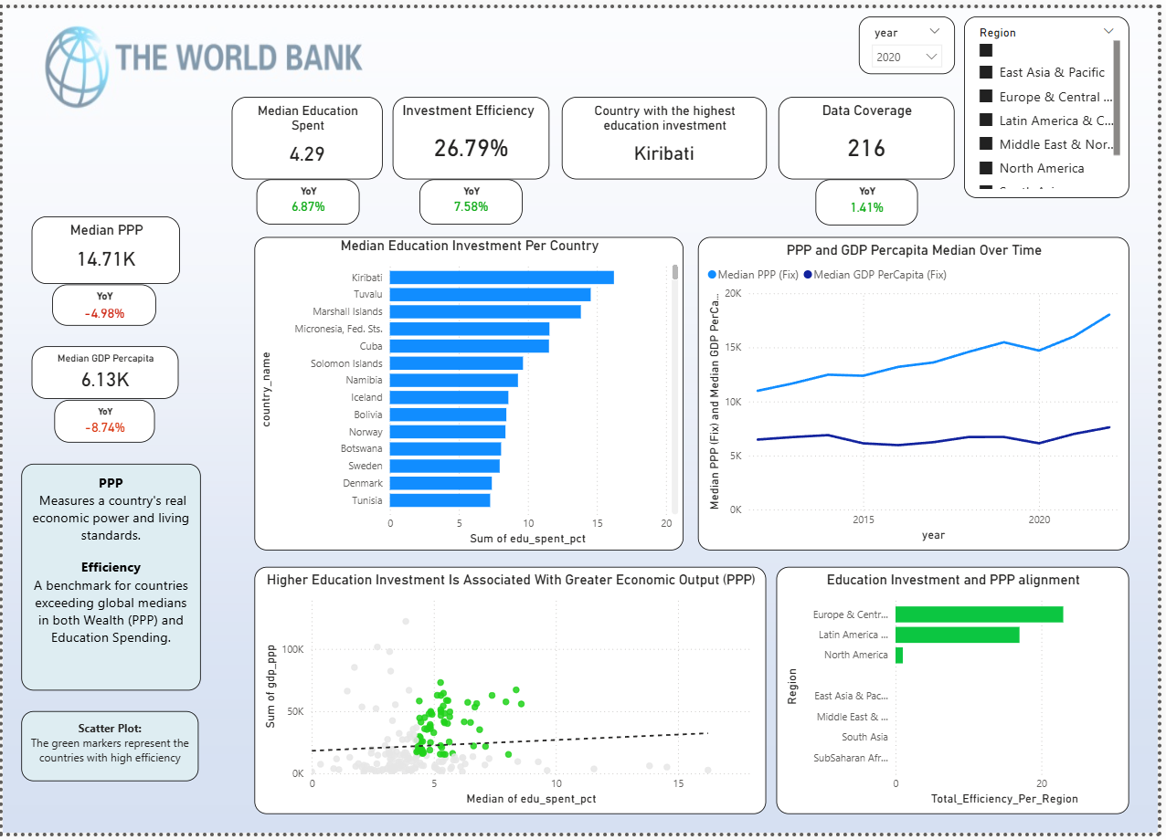

**Purpose**: The main page was designed as an executive cockpit, providing a high-level overview of the entire dataset. The goal is to enable users to grasp the core economic insights at a glance through a carefully curated selection of KPIs and strategic visualizations.

**Key Financial Indicators** (Side Panel): Complementing the main analysis, I included a dedicated side panel to track national wealth indicators:

* **Median PPP & GDP Per Capita**: These cards provide the absolute baseline for global wealth.
* **Dynamic YoY Growth:** Each financial metric is supported by a Year-over-Year (YoY) indicator. Using conditional formatting (Green for growth/Red for decline), these indicators allow for an instant assessment of economic momentum compared to the previous period.

**Key Visuals**

* **Education Spend Per Country (Bar Chart):** Displays a ranking of countries by their education investment, featuring a dynamic median line to instantly distinguish between top investors and those below the global average.
* **PPP & GDP Per Capita Median Over Time (Line Chart):** Provides a temporal analysis of economic trends. This visual allows observers to identify long-term growth patterns or specific historical events that influenced wealth distribution among the selected countries.
* **Education Investment Efficiency (Scatter Plot):** This is the dashboard's core analytical engine. It maps the relationship between Education Spending and PPP to identify how effectively nations convert investment into economic output.
  + **The Efficiency Quadrant:** Countries marked in Green represent the "Top Performers"—those that exceed the global median in both wealth and spending.
  + **Correlation Analysis**: The inclusion of a trend line helps determine if higher spending consistently leads to higher PPP across the dataset.
* **Regional Efficiency Breakdown (Bar Chart):** Aggregates efficiency performance by geographic region. It ranks regions based on the count of countries that successfully exceed both global spending and wealth medians, highlighting regional success stories.

**Contextual Guidance (Integrated Glossary)**: To ensure accessibility for a broad audience, I integrated a summary glossary directly into the UI:

* **PPP (Purchasing Power Parity):** Defined as a metric that adjusts for price level differences, allowing for a real comparison of economic power and living standards between nations.
* **Efficiency Logic:** Explained as a performance benchmark for countries that manage to outperform global medians in two critical dimensions: Wealth (PPP) and Education Spending.

**User Interaction**: To ensure a 360-degree analytical experience, I integrated dynamic "Region" and "Year" slicers that propagate through all visuals. These filters allow for a granular investigation of the data, focusing on practical usability and efficiency without losing the global context.

**6.2 – Top 5 / Bottom 5 Page**

This page provides a granular lens into the dataset by isolating the highest and lowest performers across the three primary metrics. Its primary function is to facilitate "Cross-Metric Correlation," allowing users to see if leadership in investment (Education Spend) translates directly to leadership in output (GDP/PPP).

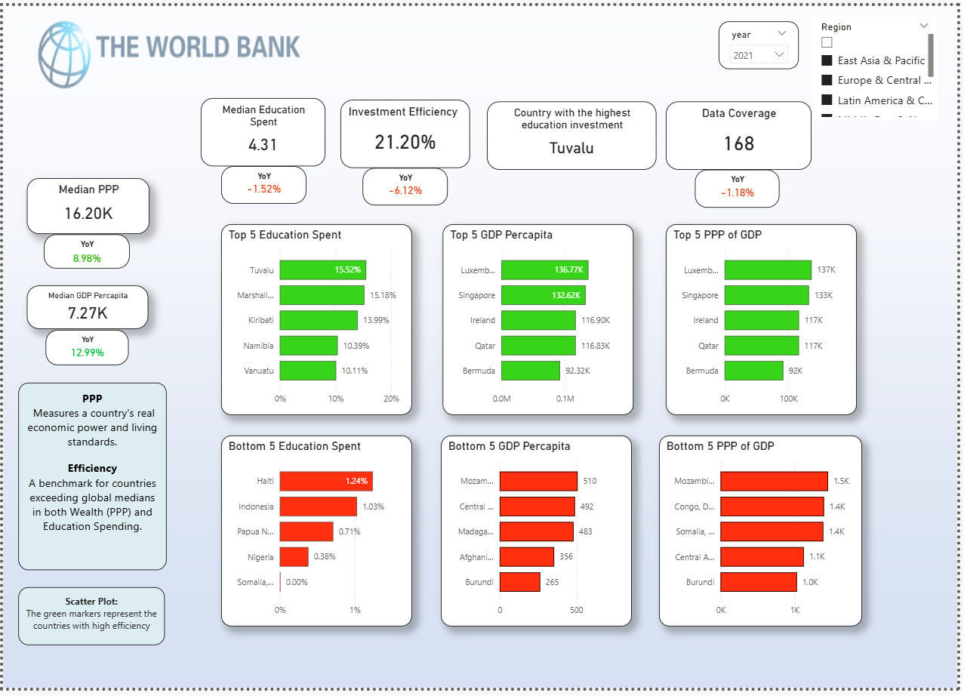

**Purpose:** The Top 5 / Bottom 5 view acts as the stress test for **Hypothesis 1 (Direct Driver)**. By juxtaposing the extremes of fiscal input against the extremes of economic output, the dashboard allows for an immediate visual audit of whether the same nations appear in both the Top Education and Top Wealth categories.

**Strategic Comparative Panels (Bar Charts)**

To offer a clear contrast, I utilized a six-panel "Rank" layout that categorizes performance into two distinct tiers:

* **Top 5 Leaderboards (Green):**
  + **Education Spend:** Highlights nations with the highest fiscal commitment (e.g., Tuvalu at 15.52% and Marshall Islands at 15.18%), testing the "High Investment" theory.
  + **GDP & PPP Per Capita:** Identifies global economic leaders (e.g., Luxembourg and Singapore).
  + **Insight:** A key finding here is the **structural disconnect**; the top wealth performers in GDP/PPP are rarely the top fiscal investors by percentage of GDP, supporting **H3 (Ecosystem View)**.
* **Bottom 5 Laggards (Red):**
  + Provides a critical view of nations at high economic risk (e.g., Burundi and Central African Republic).
  + The visual contrast between the green (top) and red (bottom) bars utilizes color theory to signal performance health, making the disparity in global wealth (from $137k in Luxembourg to $265 in Burundi) immediately apparent.

**Executive KPIs & Global Context**

To maintain continuity with the **Main Page**, the top header integrates the project's primary health indicators:

* **Median Benchmarks:** Cards for **Median Education Spent (4.31%)** and **Investment Efficiency (21.20%)** remain visible to provide a constant baseline for the rankings below.
* **Data Coverage Tracker:** A card displaying the current sample size (**168 countries**) ensures transparency regarding the breadth of the study for the selected period.
* **Secondary Financial Metrics:** Side-panel cards for **Median PPP (16.20K)** and **Median GDP Per Capita (7.27K)** provide the global average against which the Top/Bottom 5 are measured.

**Interactive Filtering & Granularity**

* **Regional & Temporal Slicers:** The inclusion of "Region" and "Year" filters allows users to drill down into specific geographic disparities (e.g., comparing the Top 5 within Sub-Saharan Africa vs. the Top 5 in Europe).
* **Trend Indicators:** Small-multiples indicators below the primary KPIs show the **YoY percentage change** (e.g., -6.12% in Investment Efficiency), adding a temporal dimension to the static rankings.

**6.3 – World Map Page**

The World Map serves as the dashboard’s primary geographic engine, providing a macro-level visualization of how education investment and wealth are distributed across the globe. By moving from tabular ranks to a spatial view, users can instantly identify regional clusters of prosperity or underinvestment.

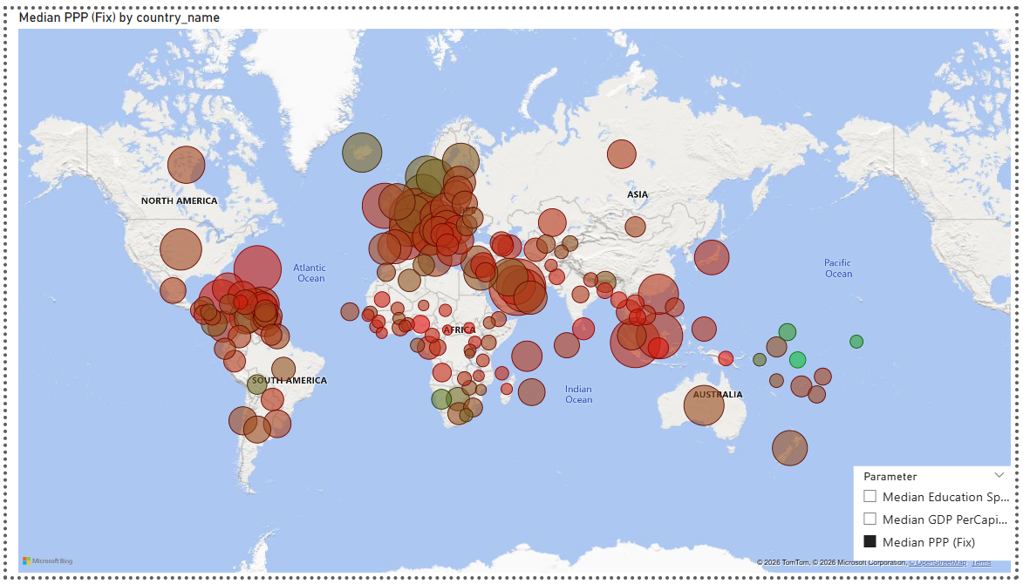

**Purpose:** The map's objective is to provide a "bird's-eye view" of global inequality. It allows observers to visually correlate geographic location with economic output, helping to identify if certain continents or regions are collectively "trapped" in low-efficiency cycles or if they share common success traits.

**Dynamic Metric Selection (Parameter Toggle)**

To maintain a clean user interface while offering deep functionality, I integrated a **Parameter Slicer**. This allows users to toggle the entire map view between the three core project metrics:

* **Median Education Spending:** Visualizes which regions are currently prioritizing fiscal "input."
* **Median GDP Per Capita:** Displays absolute economic output.
* **Median PPP (Purchasing Power Parity):** Adjusted view for real living standards and purchasing power.

**Key Visual Features**

* **Proportional Bubble Map:** I utilized bubble size to represent the magnitude of the selected metric. This enables an instant comparison of scale—for example, the massive disparity in economic bubbles between North America and Sub-Saharan Africa.
* **Heat-Map Conditional Formatting:** A divergent color scale was implemented to signify performance health.
  + **Green:** Higher results, indicating economic strength or high fiscal priority.
  + **Red/Brown:** Lower results, highlighting areas of economic vulnerability.
* **Interactive Hover (Tooltips):** By hovering over specific bubbles, users can access the exact underlying data for a country, bridging the gap between high-level visual trends and granular data points.

**6.4 – Key Insights Page**

The Key Insights page acts as the dashboard's "analytical finality." It moves away from raw data exploration to offer a structured, text-driven interpretation of the study’s most critical findings.

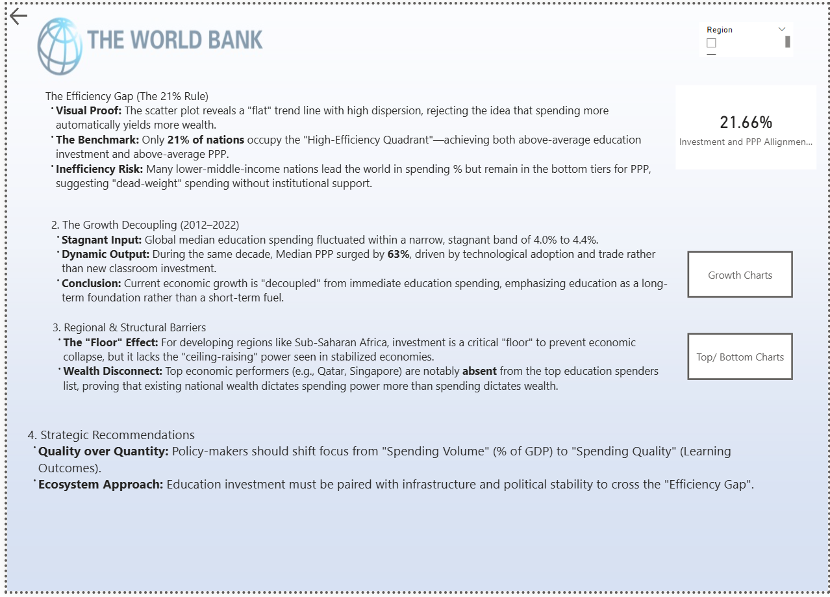

**Purpose:** This page provides stakeholders with an immediate "Value Reveal." It translates complex statistical trends into actionable economic intelligence, specifically addressing the project's core hypotheses regarding the ROI of education investment.

**Core Insight Panels**

I utilized a structured layout to categorize the findings into four strategic dimensions:

* **The Efficiency Gap (The 21% Rule):** This panel highlights the study’s primary discovery—that only **21% of nations** effectively align high fiscal spending with high economic output. It utilizes a large **KPI Card** displaying the exact efficiency percentage to anchor the narrative.
* **The Growth Decoupling (2012–2022):** Contrasts the stagnant nature of global education investment (remaining at ~4%) against the dynamic **63% surge in global PPP**, proving that short-term wealth growth is currently decoupled from immediate classroom spending.
* **Regional & Structural Barriers:** Identifies the "Floor Effect" in developing regions and highlights the "Wealth Disconnect" seen in top-tier economies like Qatar and Singapore.
* **Strategic Recommendations:** Provides a forward-looking summary, shifting the focus from "Spending Volume" to "Spending Quality".

**Interactive Design Elements**

* **Direct Navigation Buttons:** I integrated specialized buttons (e.g., "Growth Charts" and "Top/Bottom Charts") that allow users to jump instantly from a text-based insight to the specific visual that proves it.
* **Simplified UI:** This page intentionally removes complex slicers and charts to prioritize "High Scannability," ensuring the most important takeaways are clear in under 30 seconds.

**6.5 Glossary Page**

The Glossary serves as the final documentation layer, ensuring that all stakeholders—regardless of their economic background—can accurately interpret the dashboard's metrics and custom analytical logic.

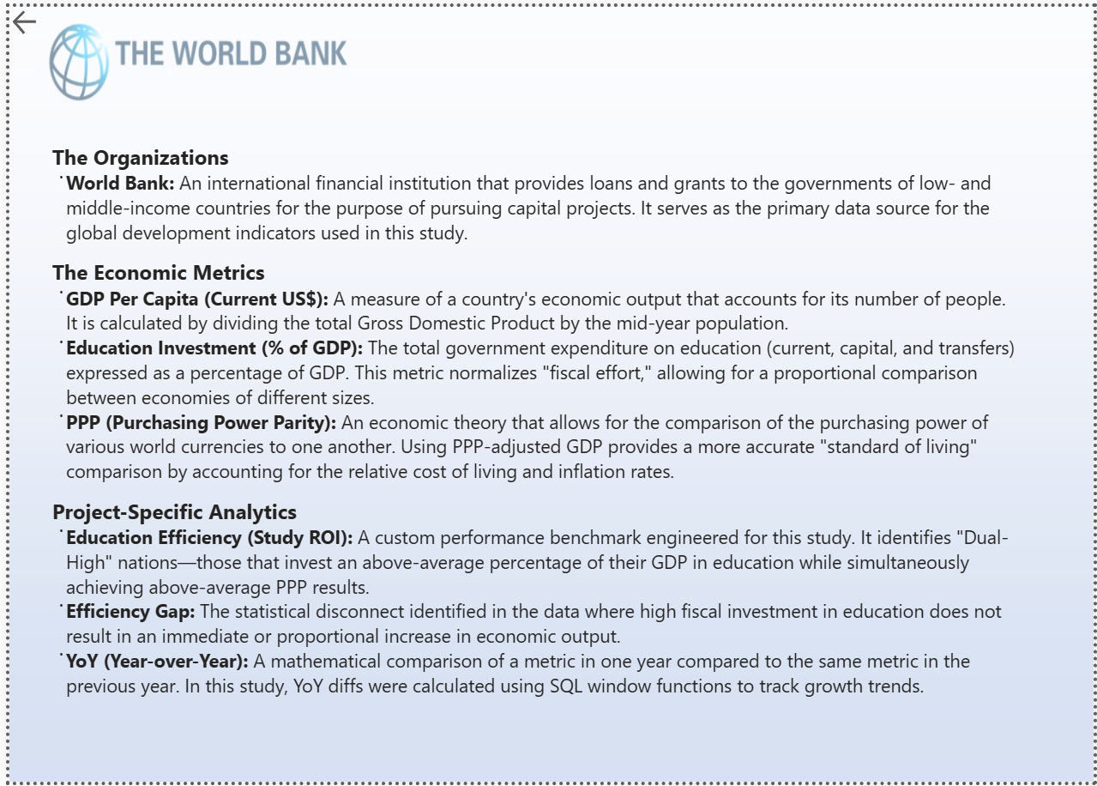

**Purpose:** This page acts as a "Single Source of Truth." It defines the authoritative data source, standardizes economic terminology, and explains the proprietary benchmarking logic used to identify global "Efficiency".

**Core Definitions**

The glossary is categorized into three critical dimensions:

* **Institutional Framework:** Defines the **World Bank** as the primary financial institution providing the global development indicators used throughout the study.
* **Economic Metrics:** Clarifies foundational concepts such as **GDP Per Capita**, **Education Investment (% of GDP)**, and **PPP (Purchasing Power Parity)**. Specifically, it highlights that PPP is used to provide an accurate "standard of living" comparison by adjusting for relative costs of living and inflation.
* **Project-Specific Analytics:** Provides the "secret sauce" behind the analysis:
  + **Education Efficiency (Study ROI):** Defines the "Dual-High" benchmark used to identify nations outperforming global medians in both wealth and spending.
  + **Efficiency Gap:** Explains the identified statistical disconnect where high fiscal investment does not yield proportional economic output.
  + **YoY (Year-over-Year):** Details the mathematical comparison of metrics against the previous year, highlighting the use of **SQL Window Functions** to track these growth trends.

**Interface Design**

* **Simplified Typography:** This page uses a clean, text-heavy layout with bolded terms for high scannability, functioning like a technical reference manual within the UI.
* **Universal Navigation:** Features a "Back" arrow button, allowing users to return to the analytical dashboards immediately after clarifying a term.

**7.1 – The Final Verdict**

The study concludes by **confirming Hypothesis 3**: Education is a critical but non-linear driver of wealth. The data suggests that for developing nations, education spending acts as a **"floor"**—necessary to prevent economic decline—while for developed nations, it acts as a **"ceiling-raiser"** only when paired with institutional stability and infrastructure.

**7.2 – Key Analytical Takeaways**

* **The 20-Year ROI Cycle**: A 10-year window is insufficient to capture the full "human capital" lifecycle; the benefits of today’s investment may only manifest in the 2035–2045 data cycles.
* **Efficiency vs. Volume**: High spending without high efficiency (as seen in the 78.8% of nations outside the "Efficiency Quadrant") suggests a **"dead-weight" loss**. Policy-makers should focus on spending **quality** (outcomes) rather than just spending **volume** (% of GDP).
* **The Decoupling Reality**: The **63% surge** in global PPP despite stagnant education spending (~4% of GDP) suggests that modern wealth is currently being driven by rapid technological adoption and global trade rather than traditional classroom investment.

**7.3 – Technical Note & Data Integrity**

To maintain high analytical accuracy, the following technical safeguards were implemented:

* **Outlier Management**: Financial anomalies (e.g., countries with extreme GDP per capita) were normalized through synchronized scaling in Power BI and SQL to prevent skewing the global median.
* **Purchasing Power Realism**: By prioritizing **PPP** over nominal GDP, the study successfully accounted for international cost-of-living differences, providing a more "human" view of economic standards.
* **SQL Logic**: Utilized NULLIF and COALESCE to ensure that data gaps in the World Bank dataset did not result in calculation errors during YoY growth analysis.

**7.4 – Future Work & Expansion**

To evolve this model from **"Exploratory"** to **"Predictive,"** future iterations will incorporate:

* **Corruption Perception Index (CPI)**: To test if institutional integrity is the primary missing link in the **"Efficiency Gap"**.
* **Digital Infrastructure**: Incorporating broadband access metrics to measure the impact of remote and digital learning on education ROI.
* **Labor Market Alignment**: Analyzing if the specific type of education (vocational vs. academic) correlates more strongly with GDP growth.

**8. Anexes**

Aqui você coloca os detalhes técnicos completos, se quiser manter o documento principal mais limpo:

* Anex A – Excel:
* Anex B – SQL
* Anex C - PowerBI

**A – Excel**

1. **A.1** Open the Power Query tab in order to unpivot the collumns



**A.2 Quickly make the first rows as headers**

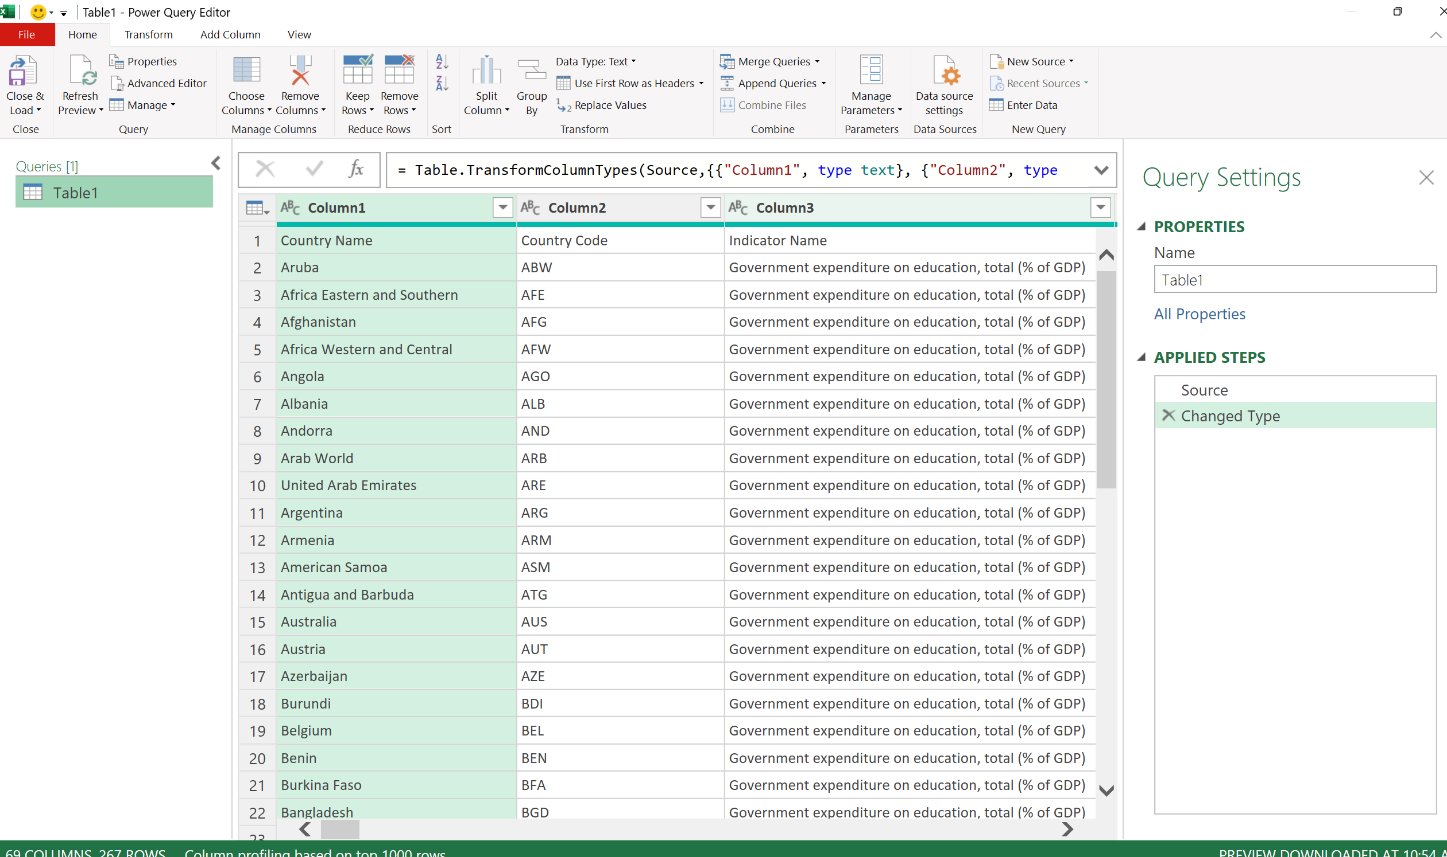

**A.3 - Unpivot other columns**

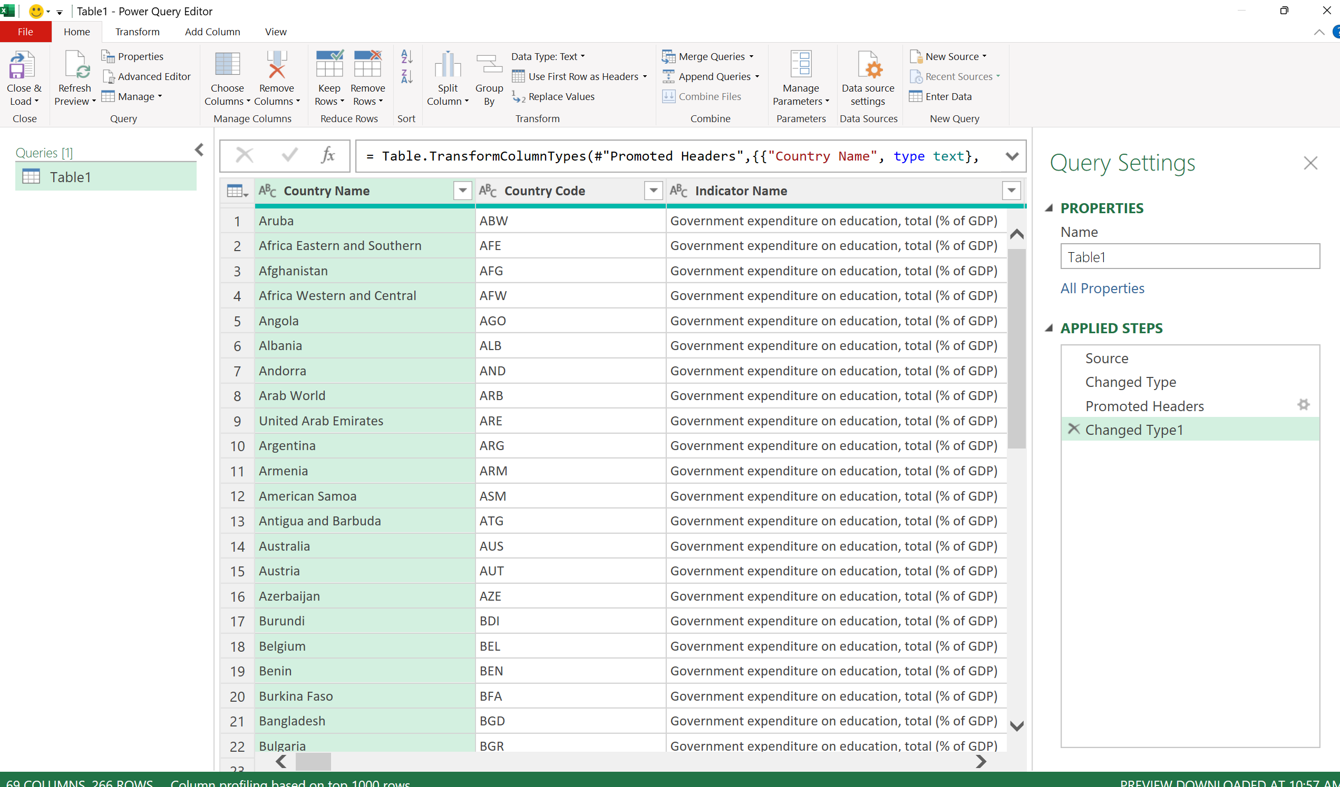

**A.4 - Remove null collumns**

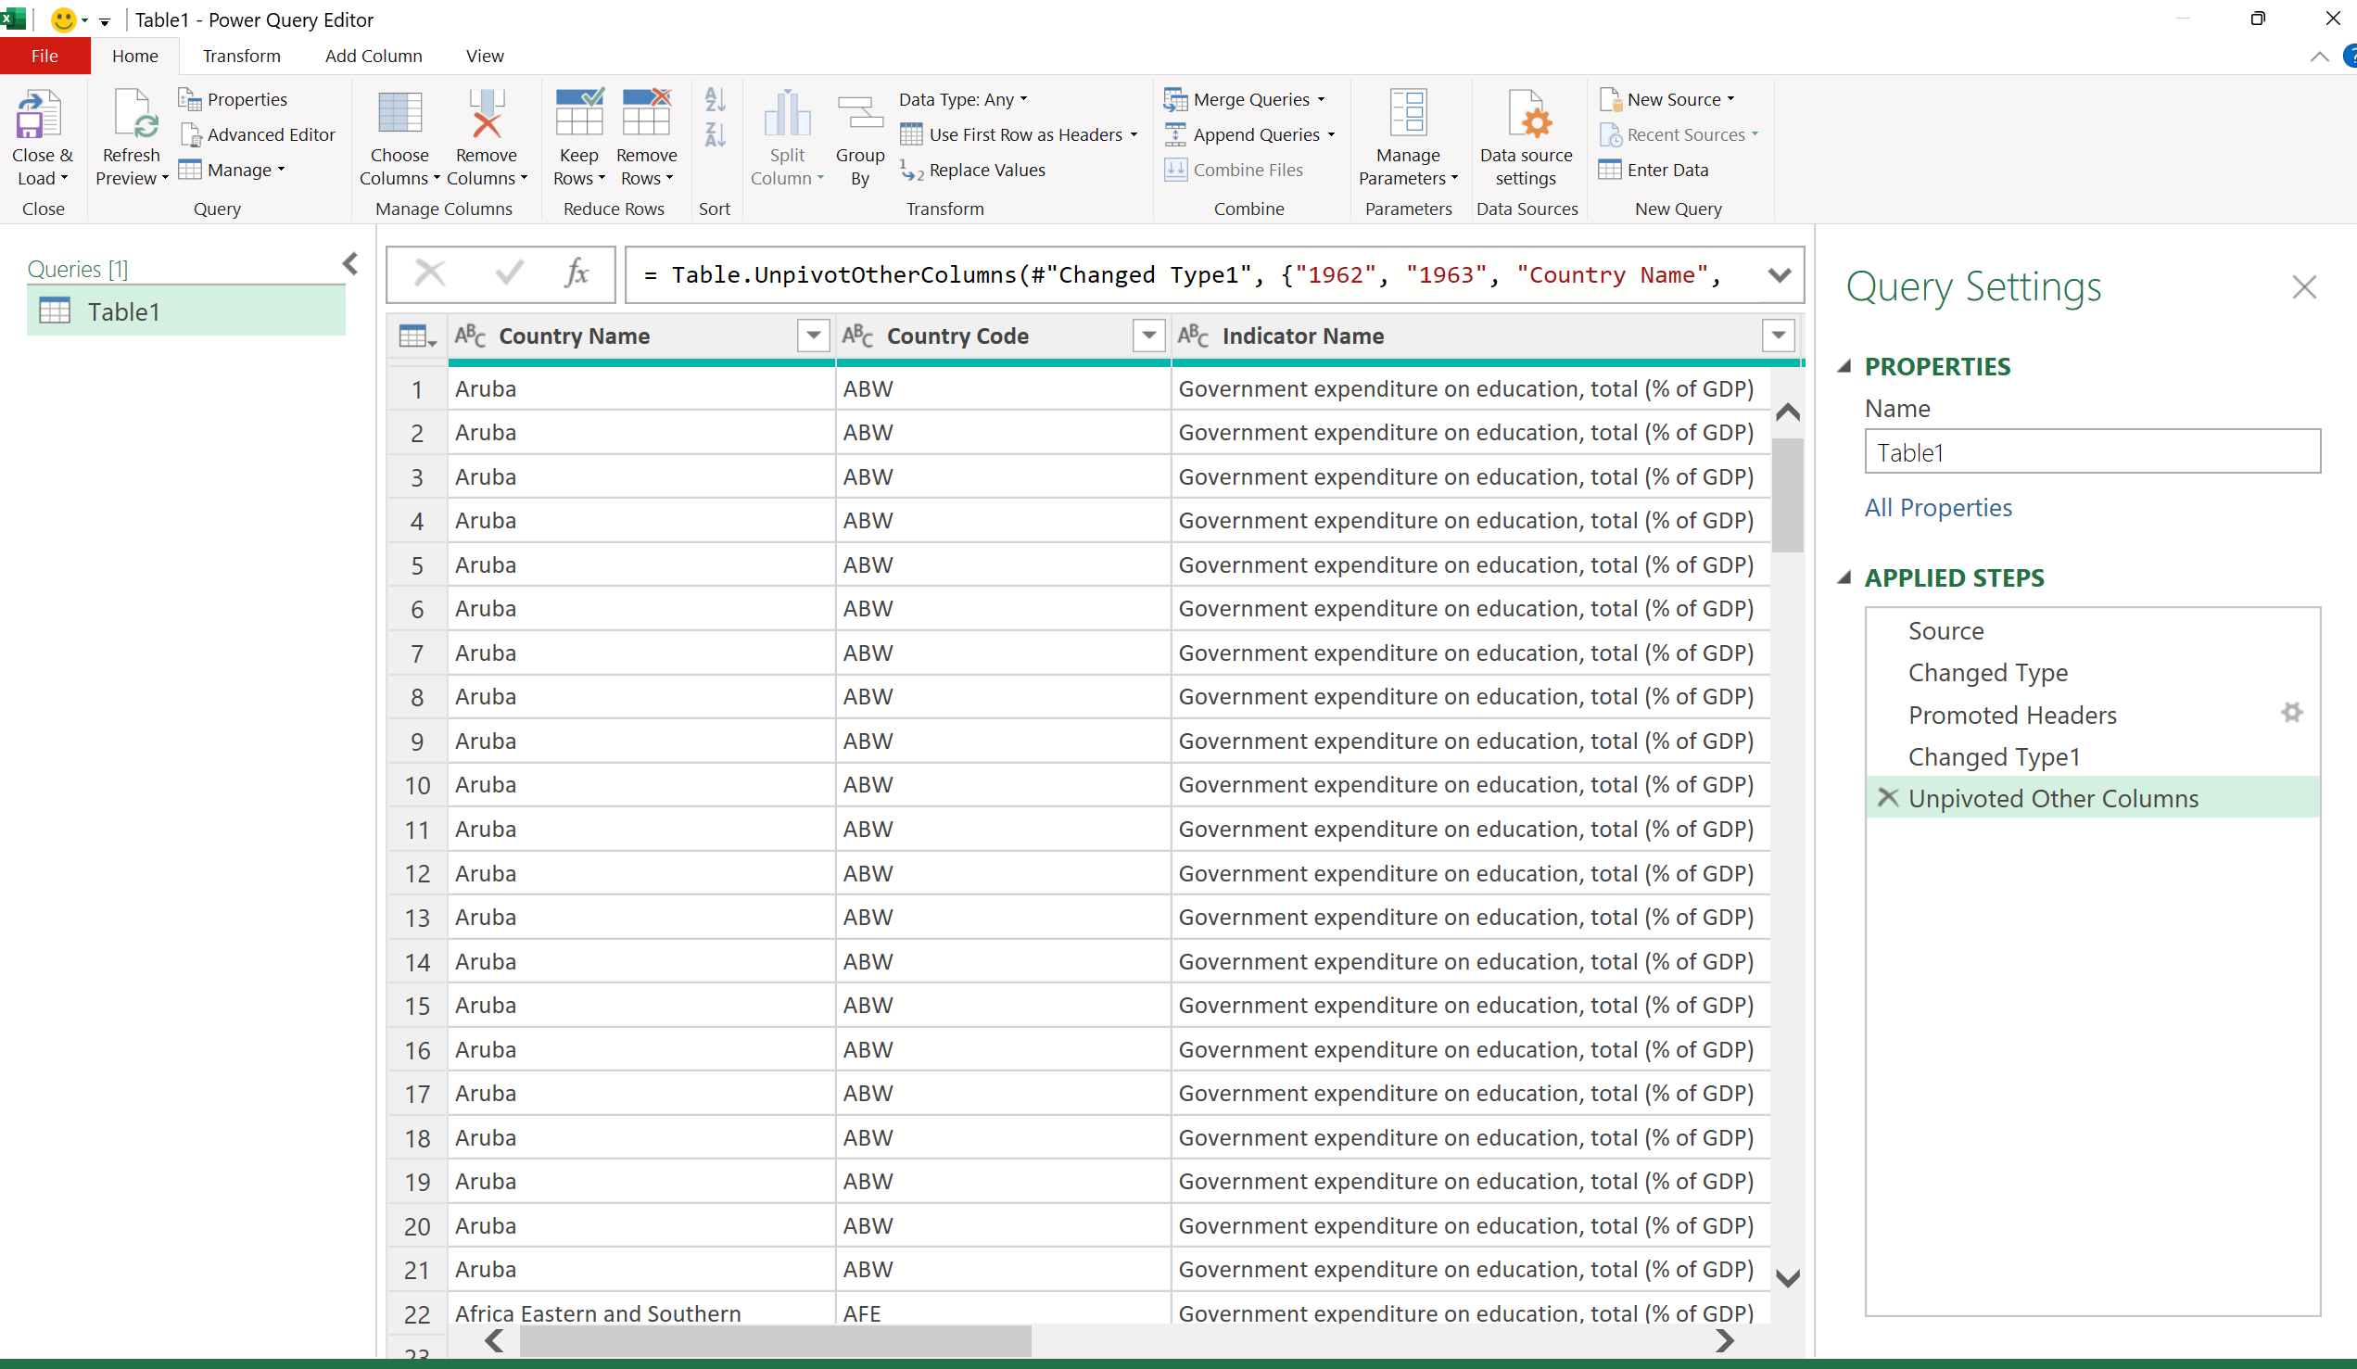

**A.5 - Turn the year as whole numbers**

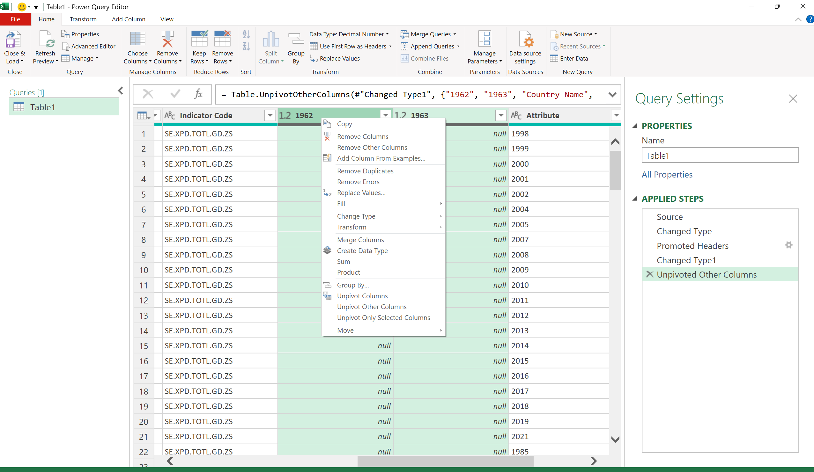

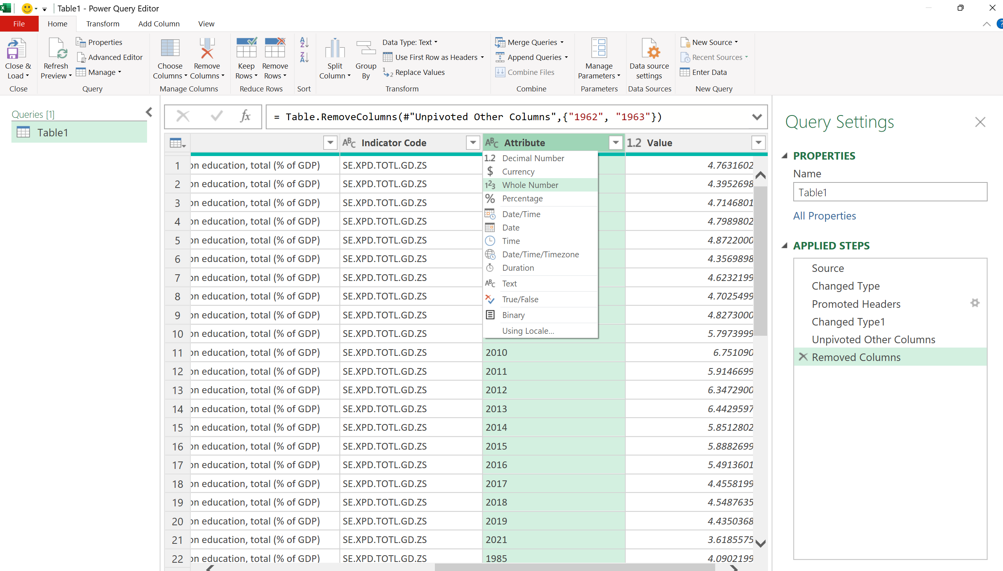

**A.6 - Now that the tables are ready, we are finally ready for SQL**

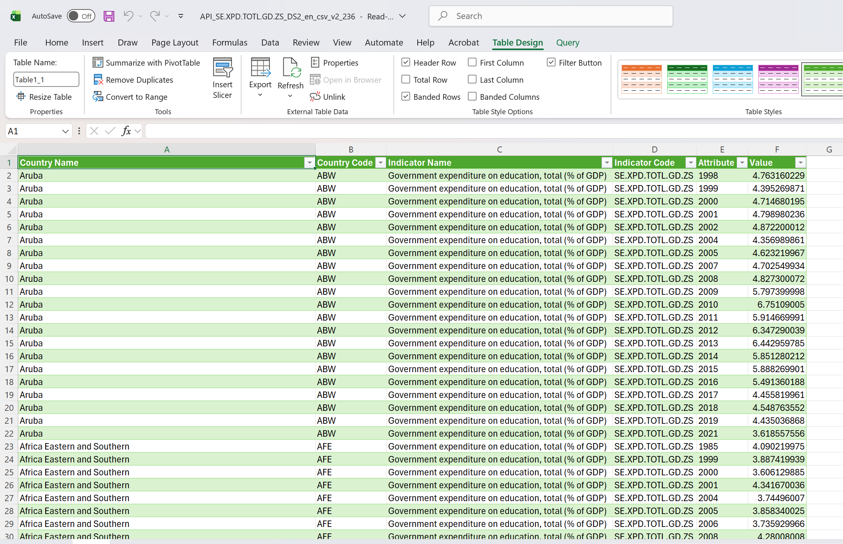

**A6 – Assess the metadata (facts table)**



**A.7 - I notice a need to sort the country names´ table**

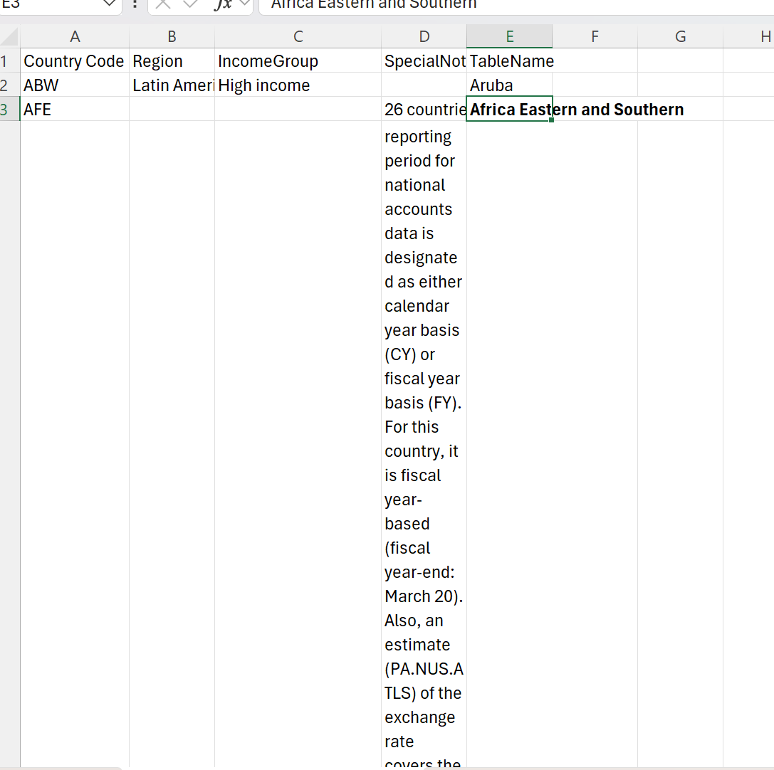

**A.8 - Transform the table into an Excel Table (CRTL + T)**

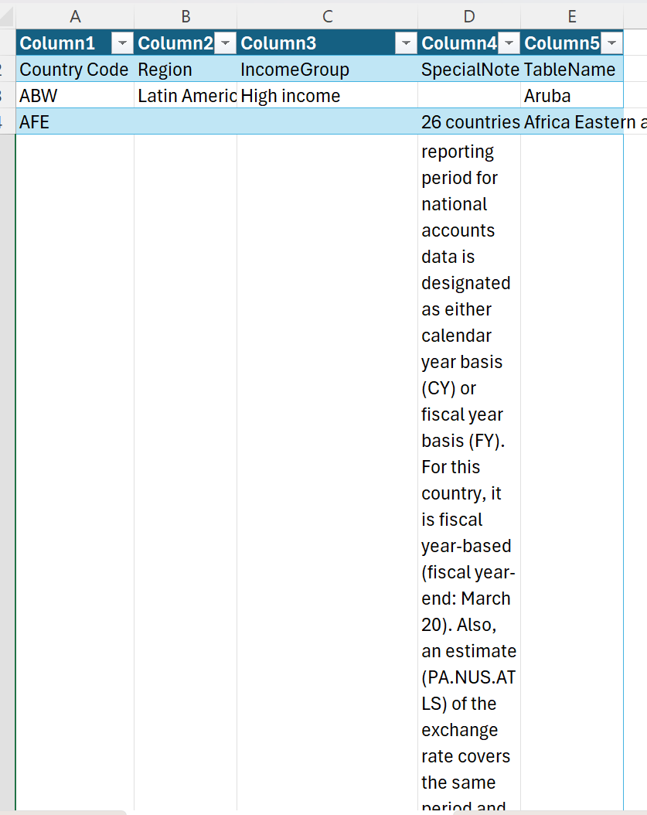

**A.9 – Use the ISBLANK formula to distinguish countries from regions in the new column Entity Type.**

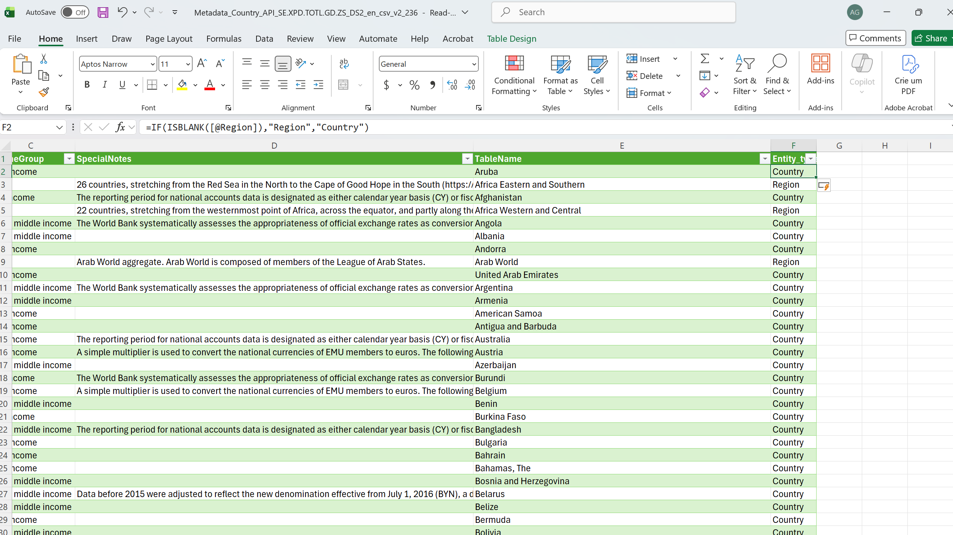

**B – SQL**

**B.1 Import the cleaned files into MySQL**

**B.2 – Global Median Education Spending (2024) calculation, using SELECT and WHERE:**



SELECT AVG(edu_spent_pct) AS avg_edu_spent_pct

FROM edu_gdp

**B.3** - **Top investor country (2022) – The country that highest amount of their GDP in education in 2022, using MAX aggregation, WHERE, GROUP BY and ORDER BY:**



WHERE year = 2022;

SELECT country_name, MAX(edu_spent_pct) AS most_edu_spent

FROM edu_gdp

WHERE year = 2022

GROUP BY country_name

ORDER BY MAX(edu_spent_pct) DESC LIMIT 1;

**B.5 - YoY Expenditure Trend – The YoY change in the global Median Education Spending, using CTEs and AVG aggregations:**

WITH eduspent_2021 AS (

SELECT

AVG(edu_spent_pct) AS avg_spent_2021

FROM edu_gdp

WHERE year = 2021

),

eduspent_2022 AS (

SELECT

AVG(edu_spent_pct) AS avg_spent_2022

FROM edu_gdp

WHERE year = 2022

)

SELECT

avg_spent_2021,

avg_spent_2022,

(avg_spent_2022 - avg_spent_2021) AS yoy_avg_eduspent,

((avg_spent_2022 - avg_spent_2021) / avg_spent_2021) * 100 AS yoy_pct_diff

FROM eduspent_2021, eduspent_2022;

**B.6 Data coverage – The number of countries being part of the study, using COUNT aggregation and WHERE:**



SELECT COUNT(country) AS number_of_countries

FROM world_bank_metadata

WHERE region IS NOT NULL;

**B.7** - **The percentage of countries above the PPP average in the last 10 years, using CTEs, CASE WHEN and CROSS JOIN:**



WITH Global_Benchmark AS (

SELECT AVG(gdp_ppp) AS global_avg

FROM ppp_gdp_edu_dim

WHERE year BETWEEN 2012 AND 2022

),

country_avg AS (

SELECT

country_name,

AVG(gdp_ppp) AS avg_country

FROM ppp_gdp_edu_dim

WHERE year BETWEEN 2012 AND 2022

GROUP BY country_name

)

SELECT

(SUM(CASE WHEN m.avg_country > g.global_avg THEN 1 ELSE 0 END) * 100.0 / COUNT(*)) AS percentage_above_avg

FROM country_avg m

CROSS JOIN Global_Benchmark g;

**B.8 – Creation of the metrics current_spend, prev_spent, yoy_diff_absolute and yoy_diff_pct using Window Functions and NULLIF**

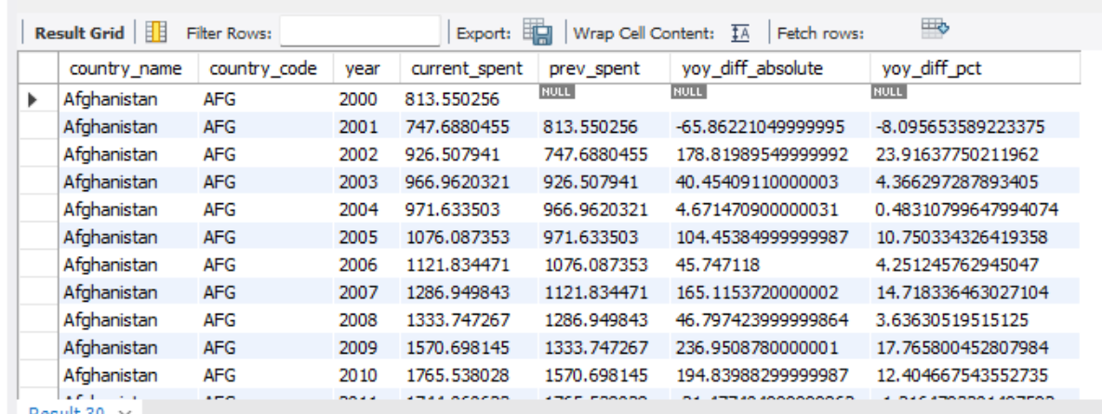

WITH ppp_transform AS (

SELECT

country_name,

country_code,

year,

gdp_ppp AS current_spent,

LAG(gdp_ppp) OVER (

PARTITION BY country_code

ORDER BY year

) AS prev_spent

FROM ppp_gdp_edu_dim

)

SELECT

country_name,

country_code,

year,

current_spent,

prev_spent,

(current_spent - prev_spent) AS yoy_diff_absolute,

((current_spent - prev_spent) / NULLIF(prev_spent, 0)) * 100 AS yoy_diff_pct

FROM ppp_transform

ORDER BY country_name, year;  
  
**B.9 – Creation of the metric is_above_global_avg, using the previously created metrics, using Window Functions, CASE WHEN and NULLIF:**



WITH ppp_base AS (

SELECT

country_name,

"country code" AS country_code,

year,

gdp_ppp,

LAG(gdp_ppp) OVER (

PARTITION BY "country code"

ORDER BY year

) AS prev_year_ppp,

AVG(gdp_ppp) OVER() AS global_avg_10yrs

FROM ppp_gdp_edu_dim

WHERE year BETWEEN 2012 AND 2022

)

SELECT

country_name,

country_code,

year,

gdp_ppp,

prev_year_ppp,

(gdp_ppp - prev_year_ppp) AS yoy_diff_abs,

((gdp_ppp - prev_year_ppp) / NULLIF(prev_year_ppp, 0)) * 100 AS yoy_diff_pct,

CASE

WHEN gdp_ppp > global_avg_10yrs THEN 1

ELSE 0

END AS is_above_global_avg

FROM ppp_base;

**B.10 – Now the main metrics were assessed, and tables were transformed. It was time to export the data, and load it on PowerBI.**

**C – Power BI**

**C.1 – Import the data from SQL to Power BI**

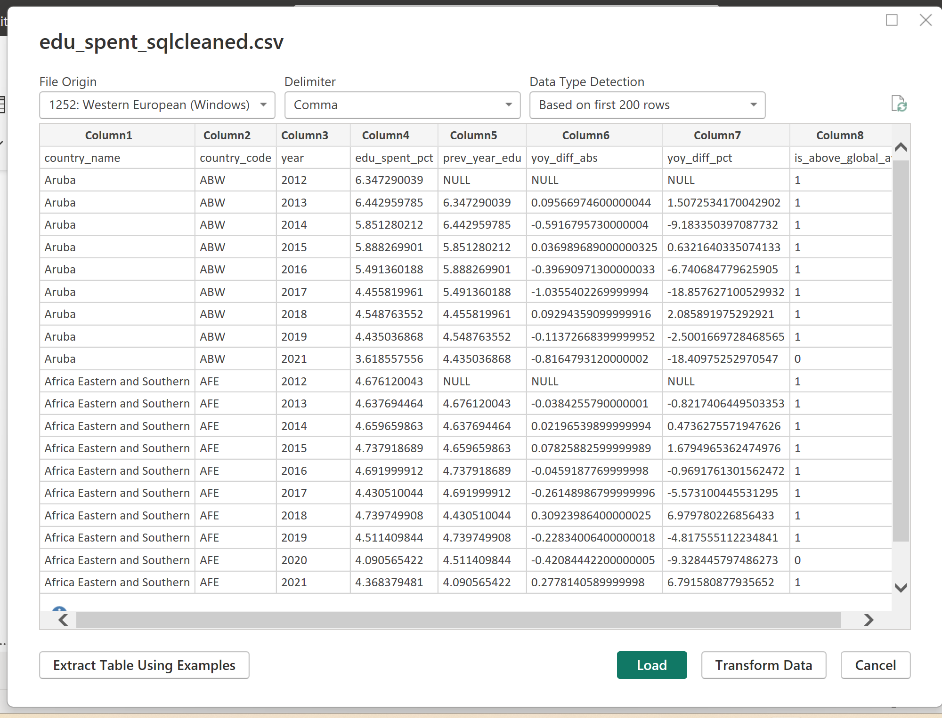

**C.2 – Use the first row as header**

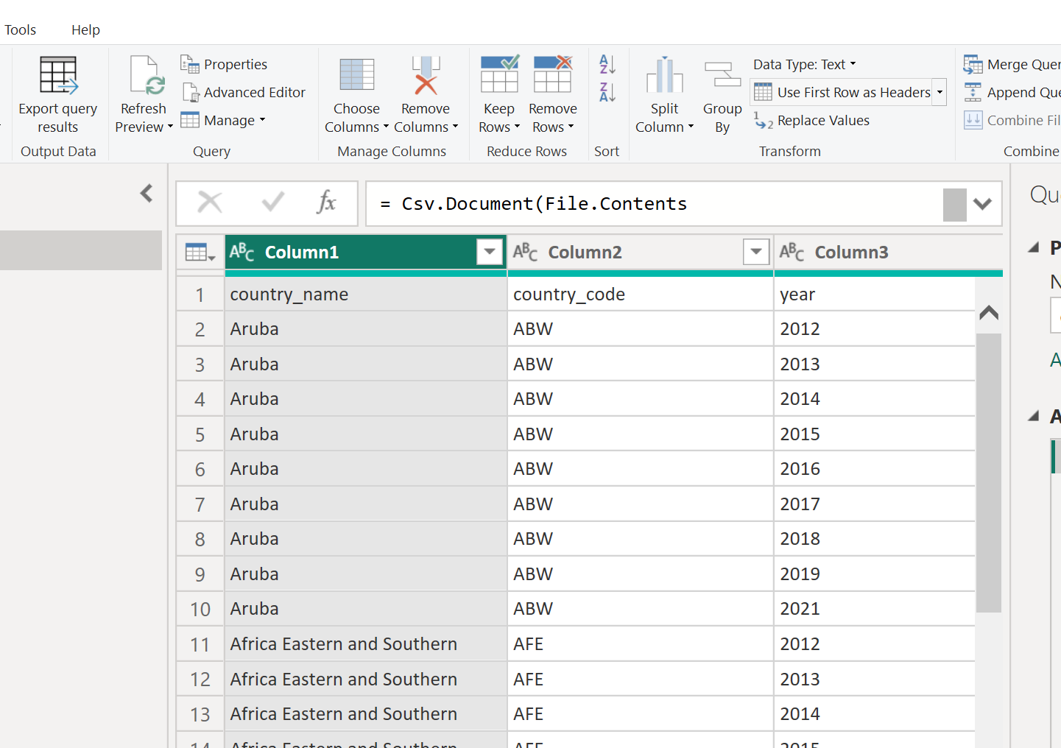

**C.3 – Change the data type:**

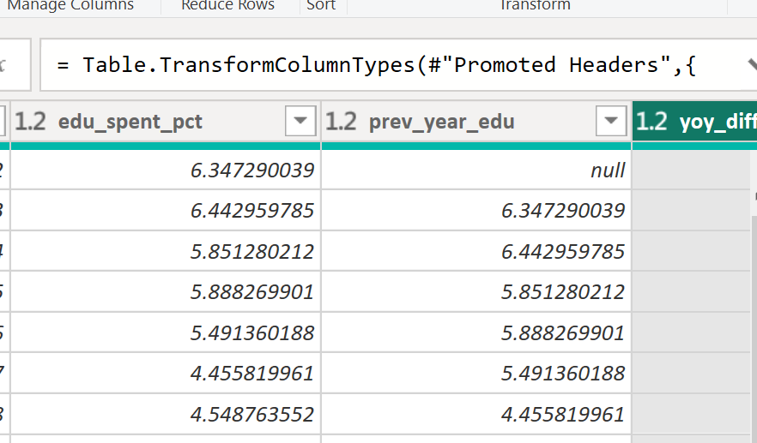

**C.4 - Making sure the relationships in the star schema were all correct**



**C.5 - DAX Dictionary:**

1. **Global Median Education Spending (2022) – The median of education spending across all countries in 2022**

Firstly, I had to create a new measure using DAX:

Median Education Spending = MEDIAN(edu_spent_sqlcleaned[edu_spent_pct])

This measure was then important as part of other subsequent measures as well as charts; I then did the same measure for other KPIs, such as the measure of **GDP Percapita and of PPP.**

1. **Education Efficiency**

Now that I had the median for each of the three main pillars calculated, I could understand how many of the countries that were above the median of education spent, were also above the PPP median – With that, I could understand if there is some level of correlation, between high levels of education investment and purchasing power.

**1. Median Education Spending**

Calculates the central value of a country's investment in education as a percentage of GDP.

Median Education Spending = MEDIAN(edu_spent_sqlcleaned[edu_spent_pct])

**2. Global Education Median**

Establishes the worldwide benchmark. It uses ALLSELECTED to ignore local filters and provide a global threshold for comparison.

Global Edu Spent Median = CALCULATE([Median Education Spending], ALLSELECTED(edu_spent_sqlcleaned))

**3. Education Investment Flag**

A binary indicator (1 or 0) that classifies whether a country’s investment is above the global median.

Flag_Edu_Investment = IF([Median Education Spending] > [Global Edu Spent Median], 1, 0)

**4. Median PPP (Purchasing Power Parity)**

Calculates the central value of a country's GDP PPP, representing its economic prosperity.

Median PPP = MEDIAN(gdp_ppp_sqlcleaned[gdp_ppp])

**5. Global PPP Median**

Sets the worldwide wealth "bar." This is the reference point used to determine if a country is considered high-wealth in the global context.

Global Media PPP = CALCULATE([Median PPP], ALLSELECTED(gdp_ppp_sqlcleaned))

**6. Wealth Flag (PPP)**

Identifies if a country’s purchasing power is higher than the global median.

Flag_PPP = IF([Median PPP] > [Global Media PPP], 1, 0)

**7. Efficient Country Match**

The core logic of the study. It returns **1** only if a country "wins" on both fronts: high investment in education **and** high economic wealth.

Efficient_Country_Match = IF([Flag_Edu_Investment] = 1 && [Flag_PPP] = 1, 1, 0)

**8. Investment Efficiency (%)**

The main Macro KPI. It calculates the percentage of countries that successfully converted high education spending into high wealth, relative to the total number of high-investing countries.

Investment Efficiency = DIVIDE(SUMX(VALUES(world_bank_metadata[country_name]), [Efficient_Country_Match]), SUMX(VALUES(world_bank_metadata[country_name]), [Flag_Edu_Investment]), 0)

1. **YoY spending trend (Median)**

Initially with SQL, I made sure to already calculate the YoY in variation in each Dim table, to make this analysis easier within PowerBI. However, I then noticed that some of the values were too high. My conclusion was that for some small countries, there were significant volatility in their data.  
This, in order not to jeopardize the conclusion of the study, I create a median using VAR, RETURN and DIVIDE:

YoY Spending Trend (Mediana) =

VAR CurrentYearMedian = MEDIAN('edu_spent_sqlclean'[edu_spent_pct])

VAR PreviousYearMedian = MEDIAN('edu_spent_sqlclean'[prev_year_edu])

RETURN

DIVIDE(CurrentYearMedian - PreviousYearMedian, PreviousYearMedian, 0)

1. **Efficiency iterator function**

Total_Efficiency_Per_Region = SUMX(VALUES(edu_spent_sqlcleaned[country_name]),[Efficient_Country_Match])

This measure uses SUMX to iterate through the country level and aggregate the binary efficiency results into a regional total. It was necessary to shift the evaluation context, forcing Power BI to sum individual country successes (1s and 0s) within each region rather than evaluating the region as a single entity. This ensures the bar chart accurately reflects the volume of efficient countries per continent, providing a clear comparative analysis of regional performance.

1. **YoY Growth Metrics (GDP & PPP)**

I noticed that when I added the cards to showcase the YoY delta for PPP and GDP, they were static. As I changed the year in the slicer, the values remained the same, which was not the case for the Education Spending card. This led me to realize there was a relationship issue between the year column and the two other fact tables.

After investigating, I realized I needed the YoY calculation to treat the selected year from the Education Spending table as the primary filter, since that relationship was already working correctly. This resulted in the following DAX:

YoY Spending Trend (Mediana) =

VAR CurrentYearMedian = MEDIAN(edu_spent_sqlcleaned[edu_spent_pct])

VAR PreviousYearMedian = MEDIAN(edu_spent_sqlcleaned[prev_year_edu])

RETURN

    DIVIDE(CurrentYearMedian - PreviousYearMedian, PreviousYearMedian, 0)

The key difference between this DAX and the one used for Education Spending is the introduction of the “SelectedYear” variable using SELECTEDVALUE, which forces the calculation to pull the specific year from the edu_spent table.  
  
**6) New Median for GDP and PPP**

After implementing the measure in point 5), I needed to test if the formula was working correctly. I noticed that the YoY results for both GDP per capita and PPP were suspiciously high, so I performed a validation check.

I created a table adding the years, the median for both GDP and PPP, and the respective YoY measures. I then noticed that the Medians for both tables were also static across all rows, which meant the YoY calculation was comparing the same total median every time. This forced me to modify the original Median calculations as follows:  
Median GDP PerCapita (Fix) =

CALCULATE(

    MEDIAN(gdp_percapita_sqlcleaned[gdp_percapita]),

    TREATAS(VALUES(edu_spent_sqlcleaned[year]), gdp_percapita_sqlcleaned[year])

)

In this step, I added the TREATAS function, which created a virtual link between the tables. This forced the measure to apply the year filter from the Education table to the GDP and PPP tables, finally allowing the medians to update dynamically and validating the YoY growth figures.

7)**Calendar table**

Initially, I attempted to resolve the filtering issues through DAX, as it seemed like an isolated error. However, when I noticed the same synchronization failure happening across my Top 5 and Bottom 5 charts—where values remained static or repeated the global total—I realized a more efficient and definitive solution was required. I decided to create a centralized Calendar Table to solve these relationship gaps once and for all. During this process, I encountered a technical error because I initially tried to use a Measure for the slicer, but I learned that Power BI requires a physical, non-measure field for this purpose. I then used the following DAX to generate the physical table:

Calendario = DISTINCT(UNION(

VALUES(edu_spent_sqlcleaned[year]),

VALUES(gdp_percapita_sqlcleaned[year]),

VALUES(gdp_ppp_sqlcleaned[year])

))  
  
After generating the table, I established 1:N relationships between the master Year column and the corresponding year fields in the Education, GDP, and PPP tables. With everything finally connected, the universal slicer began to govern the entire model. This corrected the data integrity of the rankings, ensuring that all charts now update dynamically to reflect individual country metrics for the selected year.